

CAPSTONE PROJECT REPORT
Report 3 – Software Requirement Specification

– Danang , Feb 2025 –
Table of Contents

I. Record of Changes 9
II. Software Requirement Specification 11
1. Product Overview 11
2. User Requirements 12
2.1 Actors 12
2.2 Use Cases 13
2.2.1 Diagram(s) 13
2.2.1.1 Use Case Overview 13
2.2.1.2 Use Case for Authentication 16
2.2.1.3 Use Case for Guest 16
2.2.1.4 Use Case for User 17
2.2.1.5 Use Case for Admin 19
2.2.2 Descriptions 21
3. Functional Requirements 23
3.1 System Functional Overview 23
3.1.1 Screens Flow Diagram 23
3.1.2 Screen Descriptions 23
3.1.3 Screen Authorization 25
3.1.4 Non-Screen Functions 26
3.1.5 Entity Relationship Diagram 27
3.2 Authentication feature 30
3.2.1 Sign in 30
3.2.2 Sign out 31
3.2.3 Forgot Password 32
3.3 Manage common User’s feature 34
3.3.1 View Profile 34
3.3.2 Update Profile 36
3.3.3 Searching 37
3.3.5 Change password 38
3.3.6 View Field Detail 40
3.3.7 Book Field 41
3.3.8 Paymment 43
3.3.9 View Booking History 45
3.3.10 Cancel Booking 47
3.3.11 Update Field 48
3.4 Buy Product 49
3.4.2 Update Booking Field 51
3.4.3 VIew order history 53
3.4.4 Delete Answer slot question 54
3.4.5 Manage users acoount 55
3.4.7 Manage Field 58
3.4.8 Manage Booking from user 60
3.4.10 Manage order from user 62
3.4.11 View Dashboard Revenue 63
4. Non-Functional Requirements 65
4.1. External Interfaces 65
4.1.1 User Interface 65
4.1.2 Software Interface 65
4.1.3 Hardware Interface 65
4.2. Quality Attributes 65
4.2.1 Availability 65
4.2.2 Usability 65
4.2.3 Reliability 65
4.2.4 Performance 66
4.2.5 Security 66
4.2.6 Maintainability and Extensibility 66
5. Requirement Appendix 66
5.1 Business Rules 66
Table 7. Business Rule 67
5.2 Common Requirements 67
Table 8. Common Requirements 69
5.3 Application Messages List 69
Table 9. Application Message List 72

Table of Tables

Table 1. All actors in the system 12
Table 2. Use case Description 22
Table 3. Screen Descriptions 25
Table 4. Screen Authorization 26
Table 5. Non-Screen Functions 27
Table 6. Entities Description 30
Table 7. Business Rule 67
Table 8. Common Requirements 69
Table 9. Application Message List 72
Table of Figures

I. Record of Changes 9
II. Software Requirement Specification 11
1. Product Overview 11
Figure 1. Context diagram 11
2. User Requirements 12
2.1 Actors 12
Table 1. All actors in the system 12
2.2 Use Cases 13
2.2.1 Diagram(s) 13
2.2.1.1 Use Case Overview 13
Figure 2. Pickleball47 System Use Case Diagram 15
2.2.1.2 Use Case for Authentication 16
Figure 3. Use Case for Authentication 16
2.2.1.3 Use Case for Guest 16
Figure 4. Use Case for Guest 17
2.2.1.4 Use Case for User 17
Figure 5. Use Case for User 19
2.2.1.5 Use Case for Admin 19
Below is a subsystem use case for the Admin actor. 19
Figure 6. Use Case for Admin 21
2.2.2 Descriptions 21
Table 2. Use case Description 22
3. Functional Requirements 23
3.1 System Functional Overview 23
3.1.1 Screens Flow Diagram 23
Figure 7. Screen flow diagram 23
3.1.2 Screen Descriptions 23
Table 3. Screen Descriptions 25
3.1.3 Screen Authorization 25
Table 4. Screen Authorization 26
3.1.4 Non-Screen Functions 26
Table 5. Non-Screen Functions 27
3.1.5 Entity Relationship Diagram 27
Figure 8. ERD digram 27
Table 6. Entities Description 30
3.2 Authentication feature 30
3.2.1 Sign in 30
Figure 9. Sign in 30
3.2.2 Sign out 31
3.2.3 Forgot Password 32
Figure 10.Forgot password 33
3.3 Manage common User’s feature 34
3.3.1 View Profile 34
Figure 11.View Profile 35
3.3.2 Update Profile 36
Figure 12.Update Profile 37
3.3.3 Searching 37
Figure 13.Searching 38
3.3.5 Change password 38
Figure 15.Change Password 39
3.3.6 View Field Detail 40
Figure 16. View Field Detail 40
Validation and Business Rules: 41
In normal cases: 41
In abnormal cases: 41
3.3.7 Book Field 41
Figure 17.Booking Field 42
Validation and Business Rules: 42
Normal Cases: 42
Abnormal Cases: 42
3.3.8 Paymment 43
Function Trigger: 43
Function Description: 43
Interface: 43
Data Processing: 43
Figure 18.Payment 44
Function Details: 44
Actions: 44
Validation and Business Rules: 45
Normal Cases: 45
Abnormal Cases: 45
3.3.9 View Booking History 45
Function Trigger: 45
Function Description: 45
Interface: 45
Data Processing: 45
Figure 19.Delete Personal Calendar 46
Function Details: 46
Actions: 46
Validation and Business Rules: 46
Normal Cases: 46
Abnormal Cases: 46
3.3.10 Cancel Booking 47
Function Trigger: 47
Function Description: 47
Interface: 47
Data Processing: 47
Figure 20. Cancel Booking 48
Function Details: 48
Actions: 48
Validation and Business Rules: 48
Normal Cases: 48
Abnormal Cases: 48
3.3.11 Update Field 48
Function Trigger: 48
Function Description: 48
Interface: 48
Data Processing: 49
Function Details: 49
Actions: 49
Validation and Business Rules: 49
Normal Cases: 49
Abnormal Cases: 49
3.4 Buy Product 49
Function Description: 50
Interface: 50
Data Processing: 50
Function Details: 50
Actions: 50
Validation and Business Rules: 50
Normal Cases: 50
Abnormal Cases: 50
3.4.2 Update Booking Field 51
Function Description: 51
Interface: 51
Data Processing: 51
Figure 23.Update booking field 52
Function Details: 52
Actions: 52
Validation and Business Rules: 52
Normal Cases: 52
Abnormal Cases: 52
3.4.3 VIew order history 53
Function Trigger: 53
Function Description: 53
Interface: 53
Data Processing: 53
Function Details: 53
Actions: 53
Validation and Business Rules: 54
Normal Cases: 54
Abnormal Cases: 54
3.4.4 Delete Answer slot question 54
Function Description: 54
Interface: 54
Data Processing: 54
Function Details: 54
Actions: 55
Validation and Business Rules: 55
Normal Cases: 55
Abnormal Cases: 55
3.4.5 Manage users acoount 55
Function Description: 55
Interface: 55
Data Processing: 55
Function Details: 56
Actions: 56
Validation and Business Rules: 56
Normal Cases: 56
Abnormal Cases: 56
Function Description: 57
Interface: 57
Data Processing: 57
Function Details: 57
Actions: 57
Validation and Business Rules: 57
Normal Cases: 57
Abnormal Cases: 58
3.4.7 Manage Field 58
Function Trigger: 58
Function Description: 58
Interface: 58
Data Processing: 58
Figure 28.Manage Field 59
Function Details: 59
Actions: 59
Validation and Business Rules: 59
Normal Cases: 59
Abnormal Cases: 59
3.4.8 Manage Booking from user 60
Function Trigger: 60
Function Description: 60
Interface: 60
Data Processing: 60
Figure 29.Manage Booking From user 61
Function Details: 61
Actions: 61
Validation and Business Rules: 61
Normal Cases: 61
Abnormal Cases: 61
3.4.10 Manage order from user 62
Function Trigger: 62
Function Description: 62
Interface: 62
Data Processing: 62
Function Details: 62
Actions: 62
Validation and Business Rules: 63
Normal Cases: 63
Abnormal Cases: 63
3.4.11 View Dashboard Revenue 63
Function Trigger: 63
Function Description: 63
Interface: 63
Data Processing: 63
Figure 31.Dashboarh admin 64
Function Details: 64
Actions: 64
Validation and Business Rules: 64
Normal Cases: 64
Abnormal Cases: 64
4. Non-Functional Requirements 65
4.1. External Interfaces 65
4.1.1 User Interface 65
4.1.2 Software Interface 65
4.1.3 Hardware Interface 65
4.2. Quality Attributes 65
4.2.1 Availability 65
4.2.2 Usability 65
4.2.3 Reliability 65
4.2.4 Performance 66
4.2.5 Security 66
4.2.6 Maintainability and Extensibility 66
5. Requirement Appendix 66
5.1 Business Rules 66
Table 7. Business Rule 67
5.2 Common Requirements 67
Table 8. Common Requirements 69
5.3 Application Messages List 69
Table 9. Application Message List 72

I. Record of Changes
Date | A*  M, D | In charge | Change Description
01/2/25 | A | VietNBQ | Add Product review, context, use case.
10/2/25 | A | VietNBQ | Add use case authentica Screen Flow
15/2/25 | A | VietNBQ | Use case for actor
*A - Added M - Modified D - Deleted

II. Software Requirement Specification

1. Product Overview
Pickleball47 is an online platform that specializes in providing Pickleball court booking services and shopping for related sports products. The system helps players easily search, book courts, as well as shop for necessary equipment to enhance their sports experience.
The context diagram below illustrates the external entities and system interfaces for the 1.0 release. Over time, the system will evolve with additional features, including integration with social media platforms to make it easier for sports players to find each other. This initial release includes key interactions for registering pickleball courts for everyone at any time, purchasing sports equipment to support safe play, and a court and product management system for managers.
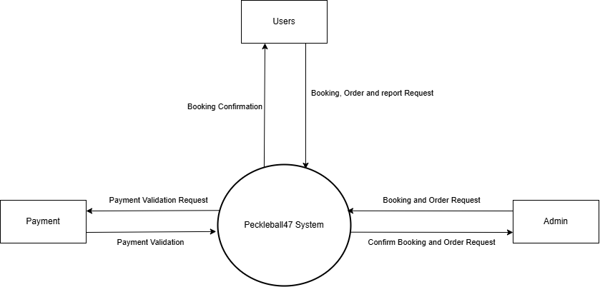

Figure 1. Context diagram

2. User Requirements

2.1 Actors

# | Actor | Description
1 | Guest | Those who have not registered an account or have not logged into the system. If necessary, visitors can contact the customer support system without logging in.
3 | Users | Customers who want to book a pickleball court to play or buy equipment for playing pickleball.
4 | Admin | The system administrator has control over all functions in the system.

Table 1. All actors in the system

2.2 Use Cases

2.2.1 Diagram(s)

2.2.1.1 Use Case Overview
Below is an overview of the use cases for the Pickleball47 system.
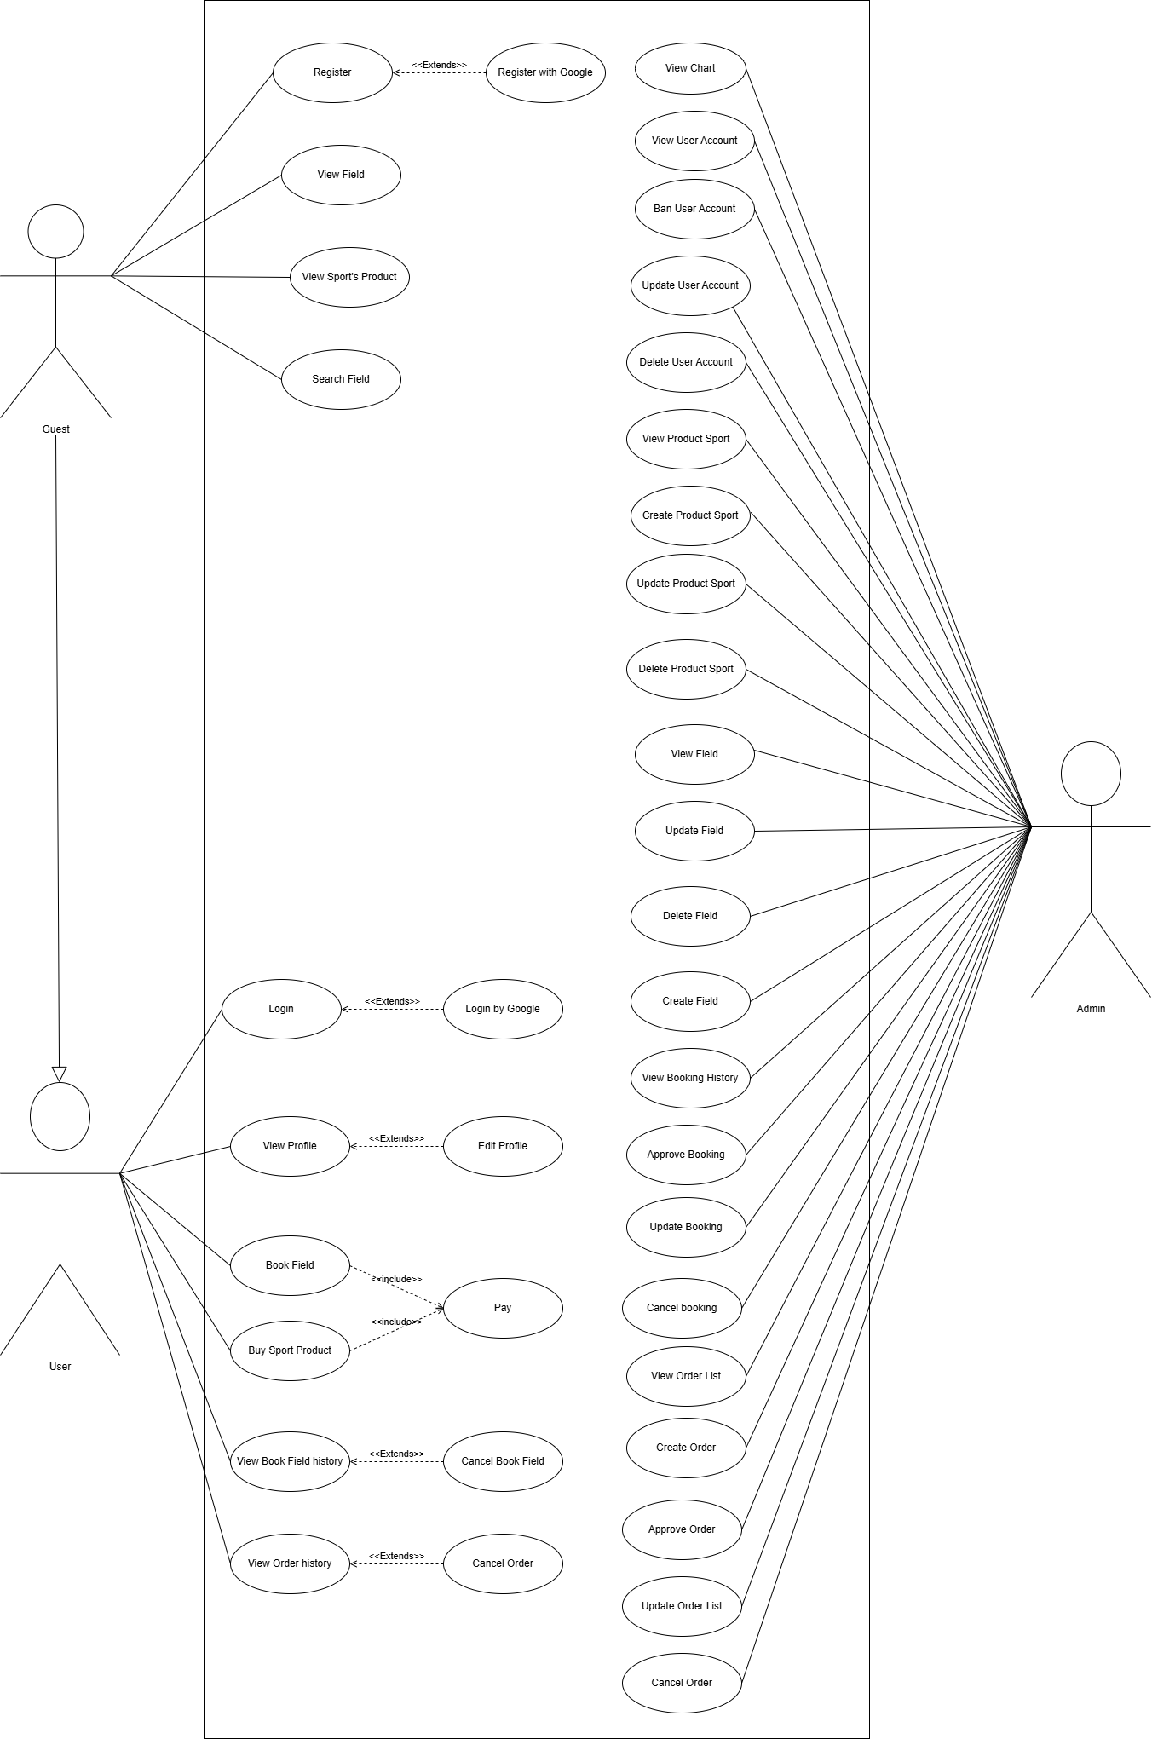

Figure 2. Pickleball47 System Use Case Diagram

2.2.1.2 Use Case for Authentication
In the Pickleball system, all users must go through an authentication process when they enter the platform. This process verifies the user's identity and ensures that only authorized individuals are granted access. The system can secure sensitive information and prevent unauthorized access by implementing authentication.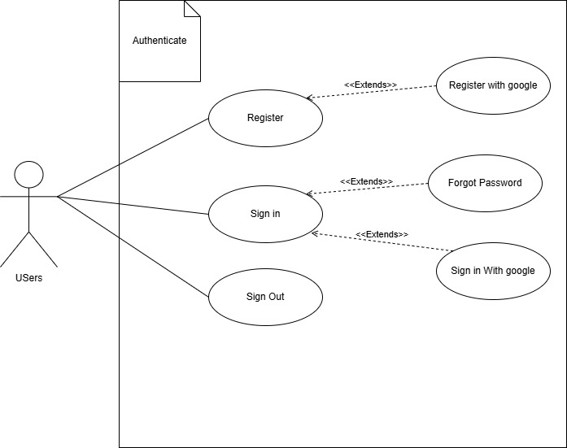

Figure 3. Use Case for Authentication

2.2.1.3 Use Case for Guest
Below is a subsystem use case for the Guest actor.
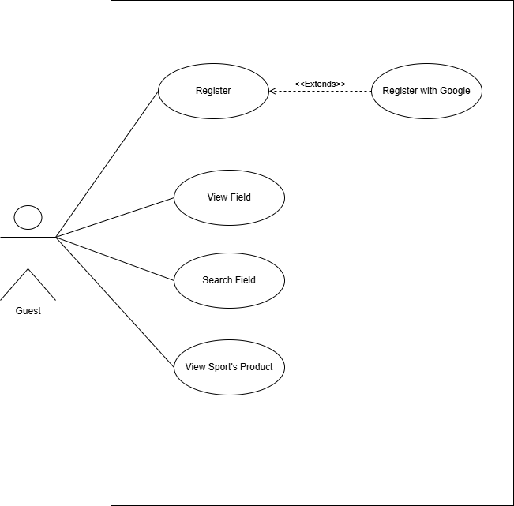

Figure 4. Use Case for Guest

2.2.1.4 Use Case for User
Below is a subsystem use case for the User actor.
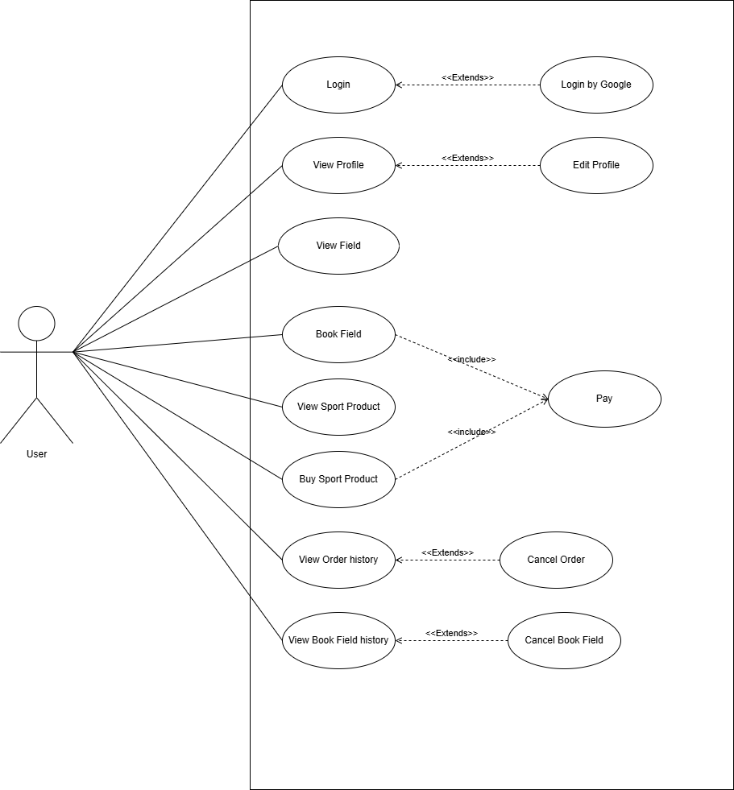

Figure 5. Use Case for User

2.2.1.5 Use Case for Admin

Below is a subsystem use case for the Admin actor.
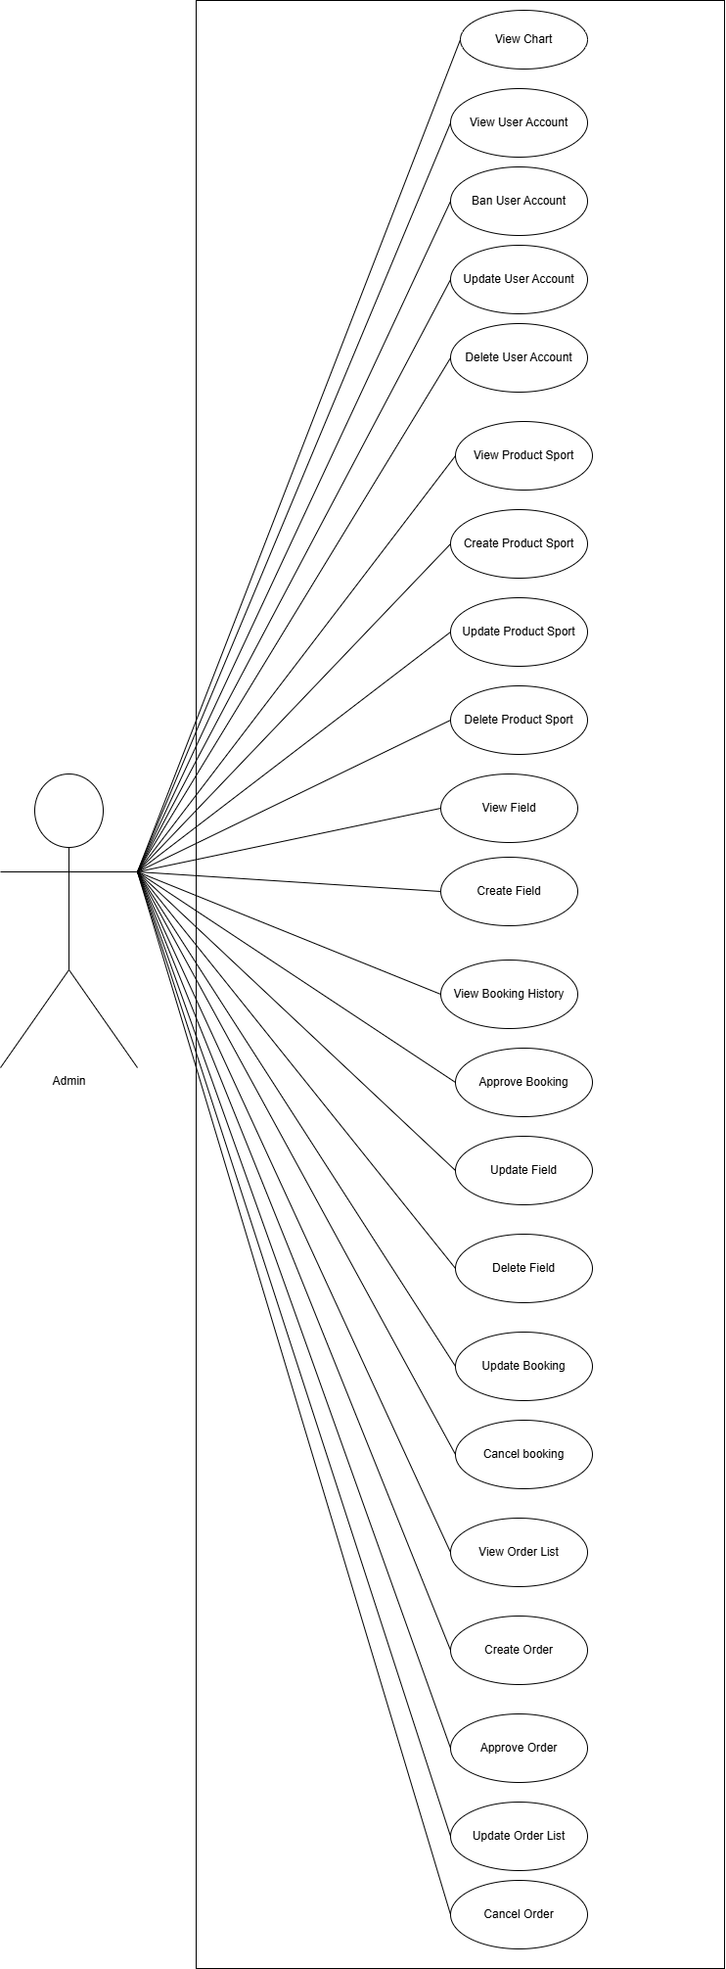

Figure 6. Use Case for Admin

2.2.2 Descriptions
Below is a summary of the use cases present in the Pickleball47 system:

ID | Use Case | Actors
1 | Sign In | User, Admin
2 | Sign Out | User, Admin
3 | Forgot Password | User
4 | View Profile | User
5 | Update Profile | User
6 | Change Password | User, Admin
7 | Searching | User, Admin
8 | Cancel Order | Admin
9 | Search Field | User, Admin
10 | View Field | User, Admin
11 | Update Order List | Admin
12 | Booking Field | User
13 | Payment | User
14 | Order Sport Product | User
15 | View Order History | User
16 | Cancel Order | User
17 | Book Field History | User
18 | Cancel Book Field | User
19 | Create Field | Admin
20 | View Booking History | Admin
21 | Update Booking | Admin
22 | Cancel Booking | Admin
23 | View Order List | Admin
24 | Create Order | Admin
25 | Approve Order | Admin
26 | View Chart | Admin
27 | View User Account | Admin
28 | Ban user account | Admin
29 | Update user account | Admin
30 | Delete user account | Admin
31 | Approve Booking | Admin
32 | Update Field | Admin
33 | Delete Field | Admin
34 | View Product Sport | Admin
35 | Create Product Sport | Admin
36 | Update Product Sport | Admin
37 | Delete Product Sport | Admin

Table 2. Use case Description

3. Functional Requirements

3.1 System Functional Overview

3.1.1 Screens Flow Diagram
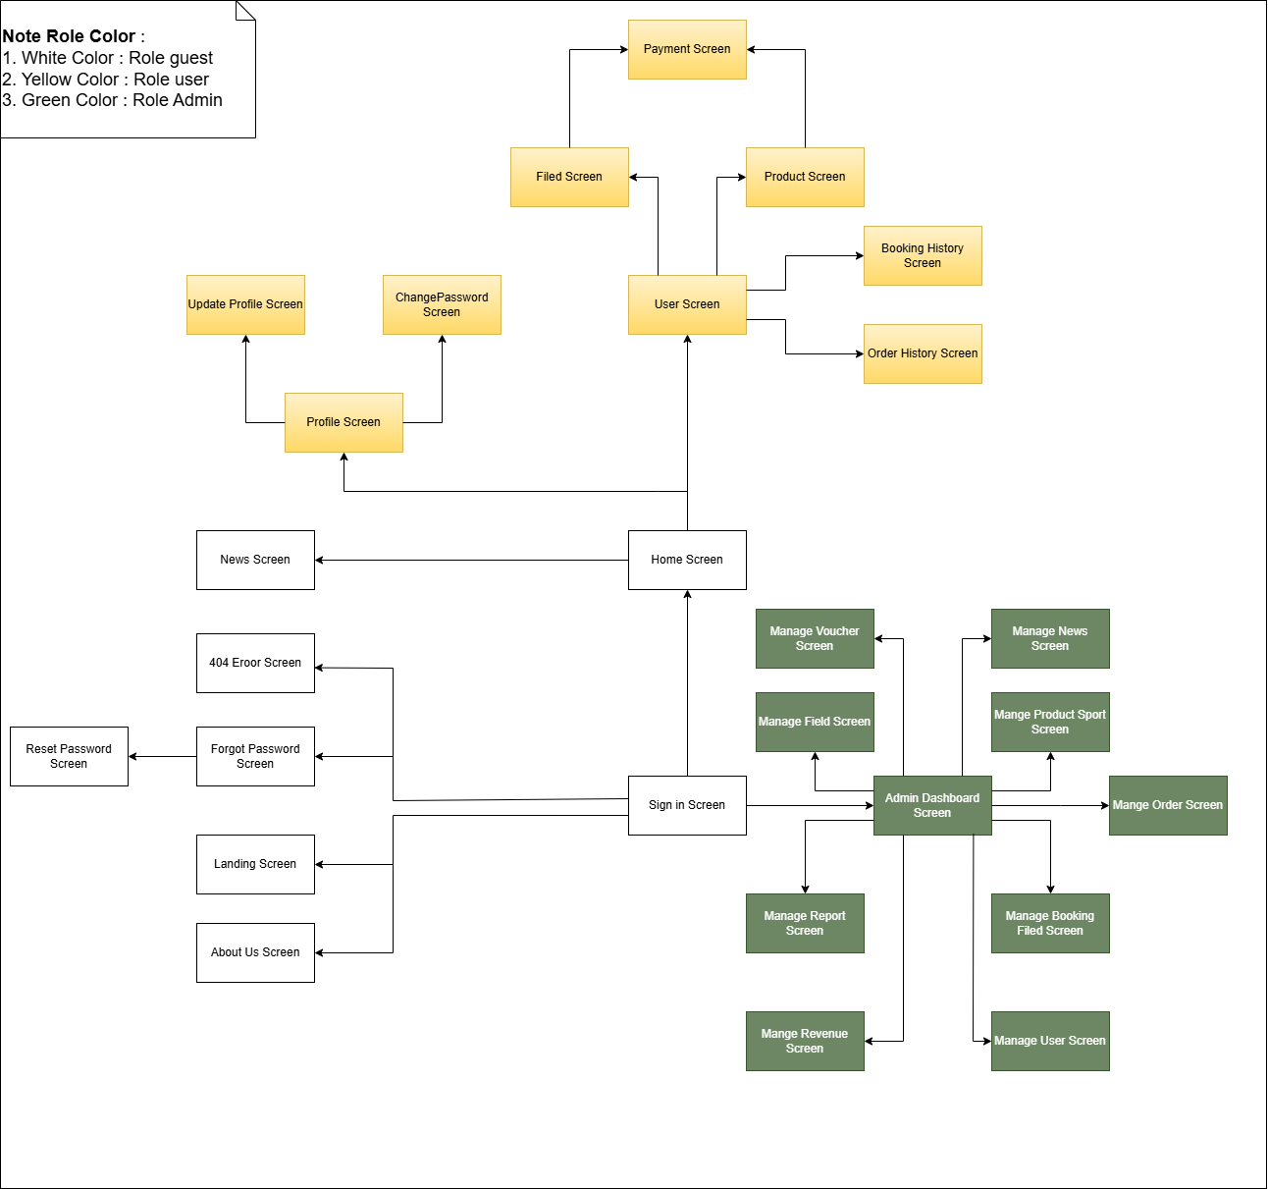

Figure 7. Screen flow diagram

3.1.2 Screen Descriptions

# | Feature | Screen | Description
1 | Authentication | Sign In Screen | Users can sign in using Google authentication or the PickleBall47 username/password combination.
2 | Authentication | Forgot Password Screen | Users can reset their password by entering their registered email and receiving instructions to recover their account.
3 | Profile | Profile User Screen | Users can view their profile information, including full name, birthday, email, phone number and other personal details.
4 | Profile | Update Profile Screen | Users can update their profile information, such as changing their full name, birthday, or personal data.
5 | Profile | Change Password Screen | Users can change their current password to a new one by providing the old one and confirming the new one.
6 | Authentication | Reset password Screen | Users need verify email to confirm steps.
7 | Authentication | 404 Error screen | Web page displayed when a user attempts to access a page that does not exist on a website
8 | Home | Landing screen | Users see when they visit an app or website.
9 | Home | About us screen | Screen provides information about Pickleball47 contact.
10 | Home | Home Screen | Main screen of Pickleball47, serving as the central hub for navigation and user interaction.
11 | User | User Screen | A personalized interface where users can view and manage details about their account, interests, and activities.
12 | User | Field Screen | The screen helps users find the field according to their needs in terms of time and field type.
13 | User | Product Screen | Display of sports products supporting pickleball play.
14 | User | Payment Screen | Screen for users to make payment.
15 | User | Booking History Screen | Displays a list of the user's booked courses and can cancel the course they just booked.
16 | User | Order History Screen | Display a list of products that the user has ordered and can cancel the order.
17 | Admin | Staff Dashboard Screen | Employee Work Area Navigation with Pickleball47.
18 | Admin | Manage Voucher Screen | Manage vouchers to apply on holidays.
19 | Admin | Manage News Screen | Screen to manage field notifications for users.
20 | Admin | Manage Field Screen | Management of pickleball courts and court type time slots.
21 | Admin | Manage Booking Field Screen | Screen to manage bookings from customers that need to be confirmed or rejected.
22 | Admin | Manage Product Sport Screen | Sports product management screen updates prices continuously and applies limited time offers.
23 | Admin | Manage Order Screen | The customer order management screen needs to review and process approval or rejection and notify the customer.
24 | Admin | Admin Dashboard Screen | Main working navigation screen for administrators.
25 | Admin | Manage Report Screen | Administrators manage requests from customers and employees for review and processing..
26 | Admin | Manage Users Screen | The site user manager displays a list of registered users on the site..
27 | Admin | Manage Revenue Screen | Admins can track revenue by quarter or month for closer management.
29

Table 3. Screen Descriptions

3.1.3 Screen Authorization
Screen | Guest | User | Admin
Landing Page Screen | X | X | X
About Us Screen | X | X | X
Sign In Screen | X | X | X
Forgot Password Screen |  | X
Reset Password Screen |  | X | X
404 Error Screen |  | X | X
Profile User Screen |  | X | X
Update Profile Screen |  | X | X
Change Password Screen |  | X | X
Home Screen | x | X | X
User Screen |  | X | X
Field Screen | x | X | X
Product Screen | x | X | X
Payment Screen |  | X
Booking History Screen |  | X | X
Order History Screen |  | x | X
Staff Dashboard Screen |  |  | X
Manage Voucher Screen |  |  | X
Manage News Screen |  |  | X
Manage Field Screen |  |  | X
Manage Booking Field Screen |  |  | X
Manage Product Sport Screen |  |  | x
Manage Order Screen |  |  | x
Admin Dashboard Screen |  |  | x
Manage Report Screen |  |  | x
Manage Users Screen |  |  | x
Manage Revenue Screen |  |  | x

Table 4. Screen Authorization

3.1.4 Non-Screen Functions

# | Feature | System Function | Description
1 | User Authentication | Sign in with Google | Sign in to the system Pickleball47 by account Google
2 | Email Sending | Forgot Password | When the user wants to recover the password, the password reset link will be emailed.

Table 5. Non-Screen Functions

3.1.5 Entity Relationship Diagram

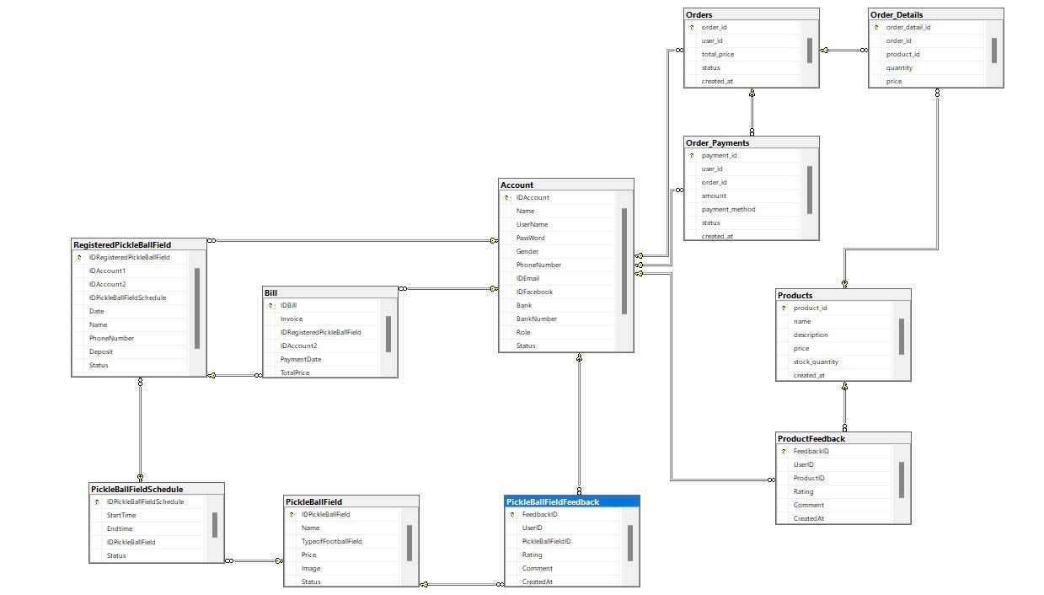

Figure 8. ERD digram
Entities Description
# | Entity | Description
1 | User | The class represents storage of the user's information for identity in the system.  - Properties:  - Id (Primary Key)  - Name  - UserName  - Password  - Gender  - PhoneNumber  - IDEmail  - IDFacebook  - Bank  - BankNumber  - Role  - Status  - Dob
2 | Bill | The class represents a bill filed deposit invoice.  - Properties:  - IDBill (Primary Key)  - Invoice  - IDRegisteredPickleBallField  - IDAccount2  - PaymentDate  - TotalPrice
3 | Order_Details | Order_Details shows details of the order that purchased the product.  - Properties:  - order_detail_id(Primary Key)  - order_id (Foreign Key to Order entity)  - product_id (Foreign Key to Product entity)  - quantity  - price
4 | Order_Payments | Order_Payments stores the payment method of user.  - Properties:  - payment_id (Primary Key)  - user_id(Foreign Key to User entity)  - order_id(Foreign Key to Order entity)  - amount  - payment_method  - status  - created_at
5 | Orders | Table stores all final orders of user.  - Properties:  - order_id (Primary Key)  - user_id(Foreign Key to User entity)  - total_price  - CreateAt  - Status
6 | PickleBallField | Table of field for pickleball sport for use can booking or view.  - Properties:  - IDPickleBallField (Primary Key)  - Name  - TypeofPickleBallField  - Price  - Image  - Status
7 | PickleBallFieldFeedback | Feedback of field from user used.  - Properties:  - FeedbackID (Primary Key)  - UserID (Foreign Key to User entity)  - PickleBallFieldID (Foreign Key to PickleBallField)  - Rating  - Comment  - CreatedAt
8 | PickleBallFieldSchedule | Schedule of field bookings according to the time frame that the user books into the field.  - Properties:  - IDPickleBallFieldSchedule (Primary Key)  - StartTime  - Endtime  - IDPickleBallField  - Status
9 | ProductFeedback | Customer feedback for sports products.  - Properties:  - FeedbackID (Primary Key)  - QuestionBankId(Foreign Key to QuestionBank entity)  - QuestionText  - AnswerOptions  - CreateAt  - UpdateAt
10 | Quiz | The exam represents a formal assessment event.  - Properties:  - ExamId (Primary Key)  - UserID (Foreign Key to User entity)  - ProductID(Foreign Key to Product entity)  - Rating  - Comment  - CreateAt
11 | Products | Products sold on the web.  - Properties:  - product_id (Primary Key)  - Name  - description  - price  - stock_quantity  - created_at
12 | RegisteredPickleBallField | RegisteredPickleBallField is a table that stores a list of registered fields..  - Properties:  - IDRegisteredPickleBallField (Primary Key)  - IDAccount1 (Foreign Key to User entity)  - IDAccount2 (Foreign Key to User entity)  - IDPickleBallFieldSchedule (Foreign Key to PickleBallFieldSchedule entity)  - Date  - Name  - PhoneNumbẻ  - Deposit  - Status  - Note

Table 6. Entities Description

3.2 Authentication feature

3.2.1 Sign in
- Function trigger:
  - Primary Trigger: The user clicks on the "Sign In" button in the navigation bar or attempts to access features that require login.
  - Secondary Trigger: The user may be automatically redirected to the sign-in page when trying to access pages that require authentication but are not logged in.
- Function description:
  - Role : User, Staff, Admin
  - Purpose: Allows users to log into their accounts using either their email and password or their Google account.
  - Interface: The sign-in interface includes the following fields:
    - Email: Input field where users enter their registered email.
    - Password: Input field where users enter their account password.
    - Google Sign-In Button: A button to log in using a Google account.
- - Screen layout:
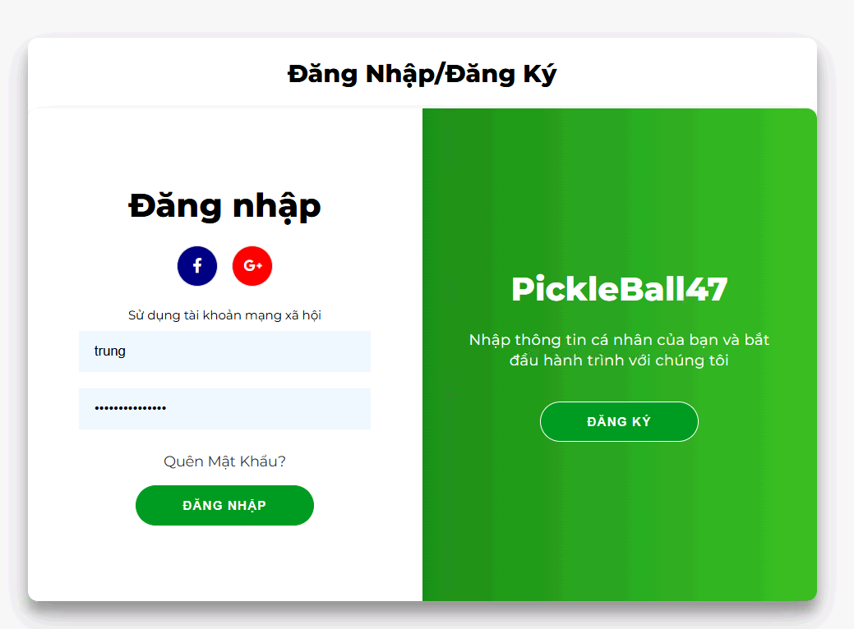

Figure 9. Sign in
- Function detail (Traditional Sign-In Flow):
  - Data Validation:
    - Email: Must be a valid email address containing “@” and a valid domain.
    - Password: Must match the password registered with the account.
    - Validation and Business Rules:
- In Normal Cases:
  - If the email and password are valid:
    - The system sends a login request to the server.
    - If successful, the user is logged in and redirected to the homepage or the intended page.
- In Abnormal Cases:
  - If the email or password is incorrect:
    - The system displays an error message like "Invalid email or password."
  - If the server is unresponsive or there's a connection issue:
    - The system will notify the user of the issue and allow them to try again later.
  - Sign In with Google uses the OAuth2 process to authenticate the user through their Google account.
    - The system will display an error message such as "Google sign-in failed, please try again".

3.2.2 Sign out
- Function trigger:
- Primary Trigger :The user clicks on the "Sign Out" button or link, which is typically located in the navigation bar, user profile dropdown, or settings menu.
- Automatic Trigger: The system may automatically log out the user after a period of inactivity for security purposes (session timeout).
- Function description:
- Role: User , Staff, Admin
- Purpose: Allow users to safely and securely log out of their account, ending their session in the system.
- Interface:
  - A simple button or link labeled "Sign Out" that the user can click to initiate the sign-out process.
  - Optional: A confirmation dialog might appear to ask if the user is sure they want to log out, depending on design preferences.
-Screen layout:
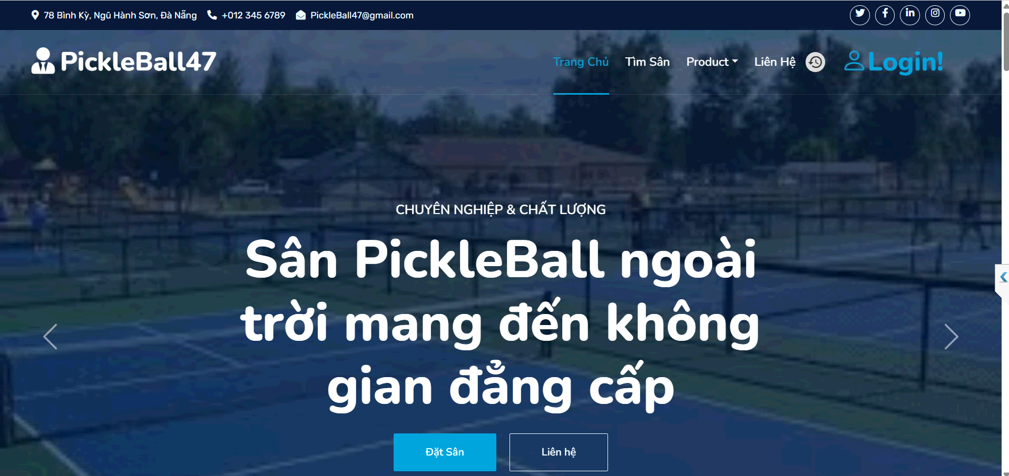
- Function Details:
Validation and Business Rules:
- In Normal Cases:
  - Once the sign-out request is sent, the system invalidates the session or token.
  - The user is redirected to the Landing Page.
- In Abnormal Cases:
  - If there’s an issue with signing out (e.g., server unresponsiveness):
    - The system will display a message such as "Unable to sign out. Please try again."
    - The user can attempt to sign out again.
  - If the user remains inactive for a predetermined period, the system automatically logs them out.

3.2.3 Forgot Password
- Function trigger:
  - The Forgot Password function can be triggered via a "Forgot Password" link from the login page.
  - Additionally, it can be accessed from a direct link sent to the user’s email when they request password recovery.
- Function description:
  - Actors/Roles: Unauthenticated users who have forgotten their password or users who wish to reset their password.
  - Purpose: To allow users to recover or reset their account password in case they forget it.
  - Interface: The system displays a form asking the user to enter the email associated with their account.
  - Data processing: After the user submits their email, the system verifies if the email exists in the database. If it does, the system sends a password reset link to the provided email.
- Screen layout:
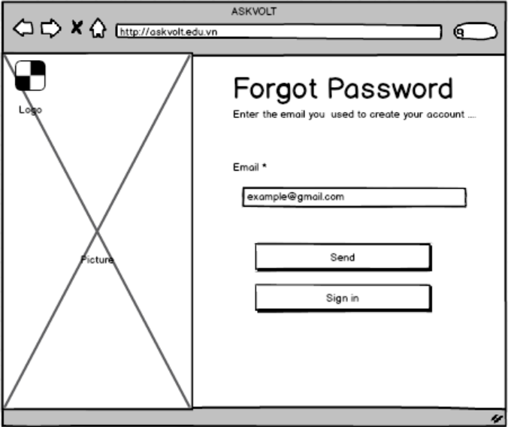

Figure 10.Forgot password
- Function detail:
  - Data:
    - Email: Required, must be a valid email format.
  - Validation and business rules:
    - In normal cases:
      - If the provided email is valid and exists in the system, the system will send a password reset link to the user's email address.
      - The user will receive an email with a link to a page to enter a new password.
      - The new password must meet the system’s password strength requirements (e.g.,at least 8 characters, must include at least 1 uppercase letter, 1 lowercase letter, 1 number and 1 special character).
  - In abnormal cases:
    - If the email does not exist in the system, the user will receive an error message like "Email not found in our records."
    - If the system encounters a failure in sending the reset email (e.g., server issue or network error), an error message will be displayed, and the user will be advised to try again later.
    - If the user tries to reset their password multiple times within a short period, the system may lock the reset function temporarily as a security measure to prevent abuse.

3.3 Manage common User’s feature

3.3.1 View Profile
- Function Trigger:
  - User-initiated: The user accesses their profile by selecting the "Profile" option from the navigation bar or a dropdown menu linked to their account.
  - System-initiated: After registration or login, the system may automatically redirect users to the profile page to encourage updating incomplete profile information.
- Function Description:
  - Actors/Roles: Any authenticated user (User, Admin).
  - Purpose: To allow users to view and manage their account information, including their name, email, role, and any additional details provided.
  - Interface:
  - Displays essential user details such as:
    - Full Name
    - Phone Number
    - Email Address
    - Gender
    - Facebook Link
    - Name Bank
    - Bank Number
- Data Processing:
  - The system retrieves the user's profile information from the database and displays it in a clear, readable format.
- Screen Layout:
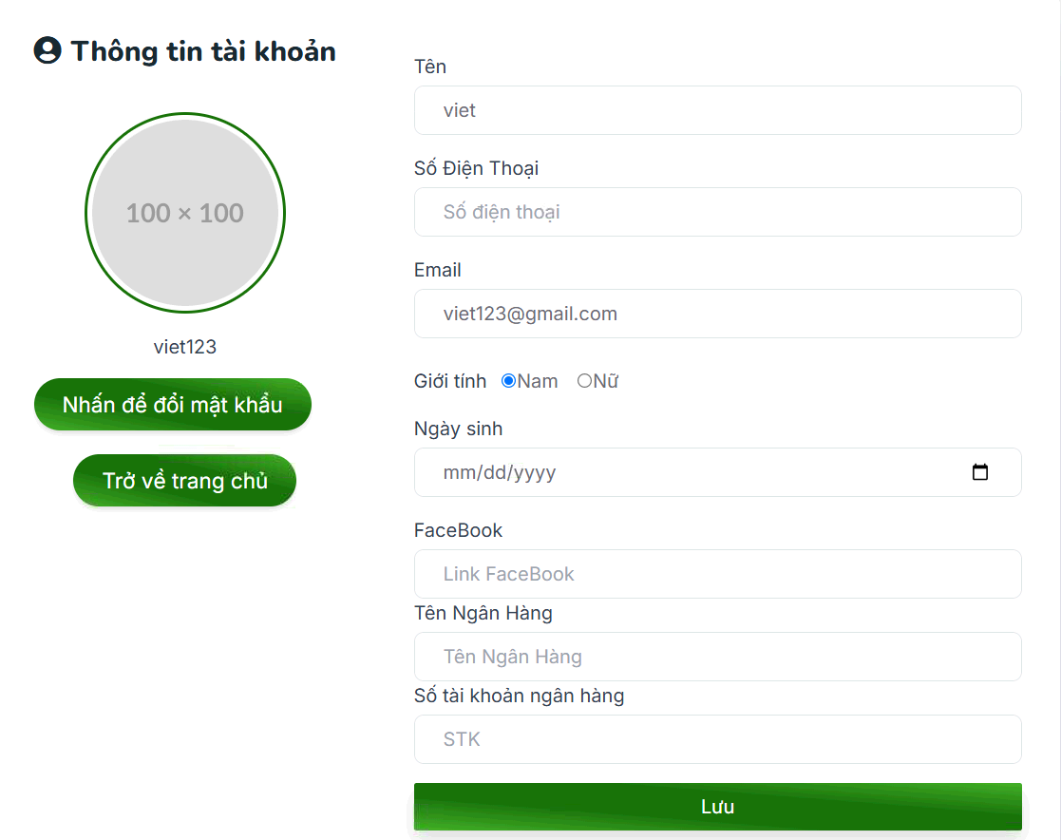

Figure 11.View Profile
- Function Details:
  - Data Requirements: The system must retrieve the necessary user data from the database (e.g., full name, username, email, role, optional fields).
- Actions:
  - View personal information: Users can review their stored details on the profile page.
  - Update Profile: Users can navigate to the "Update Profile" section to modify or add new information.
- Validation and Business Rules:
  - In normal cases:
    - The user profile information is retrieved and displayed correctly.
    - All profile details must be consistent with the data stored in the database.
  - In abnormal cases:
    - If the system fails to retrieve the profile data (e.g., due to a server issue), an error message will be displayed along with a "Retry" option.
    - If the user’s session has expired or is invalid, the system will automatically redirect the user to the login page to re-authenticate.

3.3.2 Update Profile
- Function Trigger: Users access the "Update Profile" option from their profile page.
- Function Description:
  - Actors/Roles: Any authenticated user (Student, Teacher).
  - Purpose: To allow users to update their personal information, such as name, email, phone number, and other relevant details.
  - Interface:
    - Full Name
    - Phone Number
    - Email Address
    - Gender
    - Facebook Link
    - Name Bank
    - Bank Number
- Data Processing:
  - When the user submits their changes, the system sends the updated data to the server, which validates and stores the new information in the database.
- Screen Layout:


Figure 12.Update Profile
- Function Details:
  - Data Requirements: The system needs the updated user information to be submitted by the user.
- Actions:
  - Edit profile information: Users can modify fields like name, email, and phone number.
  - Save Changes: The system validates and stores the updated information.
  - Cancel Changes: Users can discard changes and return to the profile view without saving.
- Validation and Business Rules:
  - In normal cases:
    - The system successfully updates and saves the profile information after validation.
    - Any changes made are immediately reflected in the user's profile view.
  - In abnormal cases:
    - Invalid input: If the user provides invalid data (e.g., incorrectly formatted email or missing required fields), an error message will appear, prompting the user to correct the issue before resubmitting.
    - Failed update attempts: If the system fails to process the update (e.g., due to a server issue), the user will be informed of the failure and given the option to retry or cancel the changes.

3.3.3 Searching
- Function Trigger: Users can access the search feature from the navigation bar about classes, materials, or other content.
- Function Description:
  - Actors/Roles: Any authenticated user (Student, Teacher).
  - Purpose: To allow users to search for content within the system like subjects, class name, or system resources.
  - Interface: A search bar or input field where users can enter queries related to:
    - Class name
- Data Processing:
  - The system processes the user's search input, retrieves matching data from the server, and displays relevant results based on the query.
- Screen Layout:
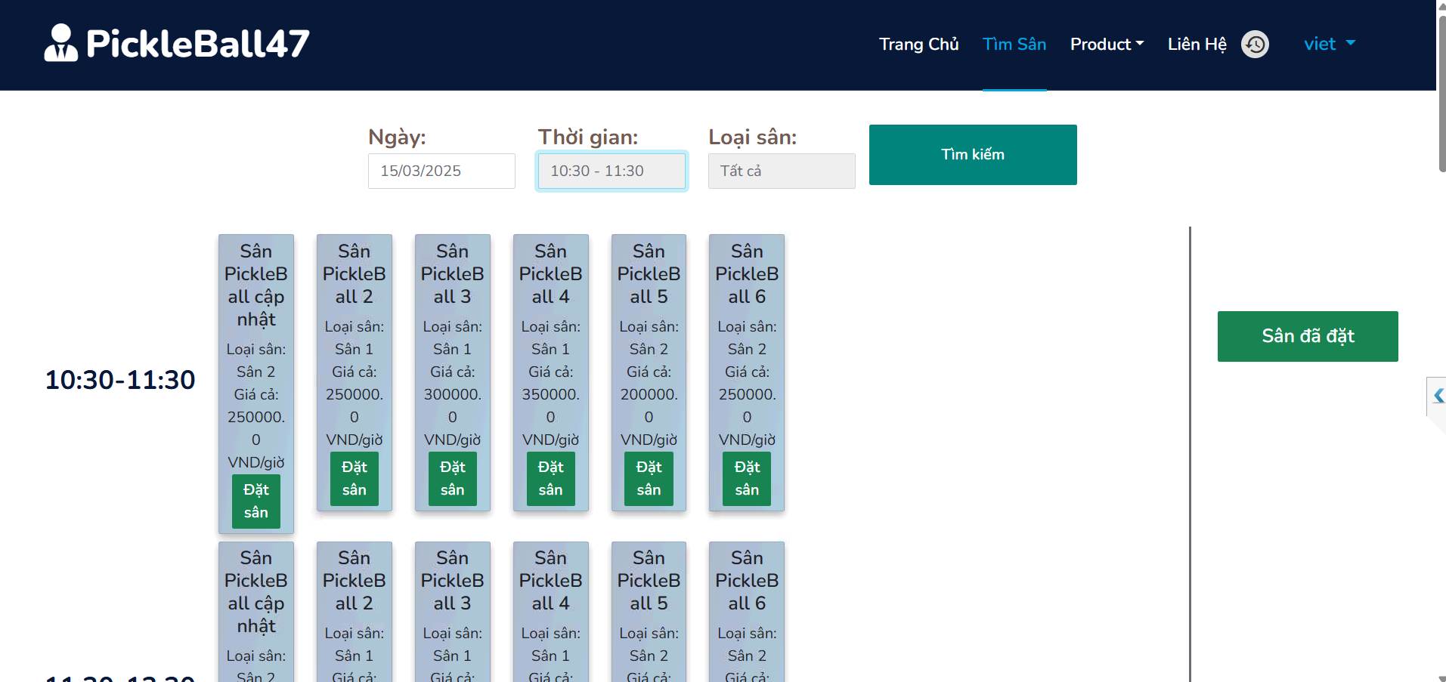

Figure 13.Searching
- Function Details:
  - Data Requirements: The system requires the search query and access to corresponding data from the server (e.g., user profiles, notifications, or content repositories).
  - Actions:
    - Enter search query: Users input keywords or phrases into the search bar.
    - View results: The system displays results related to the query, such as users, content, or notifications.
- Validation and Business Rules:
  - In normal cases:
    - The system successfully retrieves and displays search results that match the query.
    - Results are filtered based on the user's role and access permissions (e.g., Admins may see broader data than Students).
- In abnormal cases:
  - No results found: If the search returns no matches, the system will display a message such as "No results found."
  - System errors: If server or connection issues are preventing the search from completing, an error message will appear with a "Retry" option or instructions to try again later.

3.3.5 Change password
- Function Trigger:The user selects the "Change Password" option from their profile settings or a security section.
- Function Description:
  - Actors/Roles: Any authenticated user (User, Admin).
  - Purpose: To allow users to securely change their account password.
  - Interface:
    - Current Password
    - New Password
    - Confirm New Password
- Data Processing:
  - The system validates the user’s current password and ensures the new password meets security and complexity requirements (e.g., length, special characters) before saving the changes.
- Screen Layout:
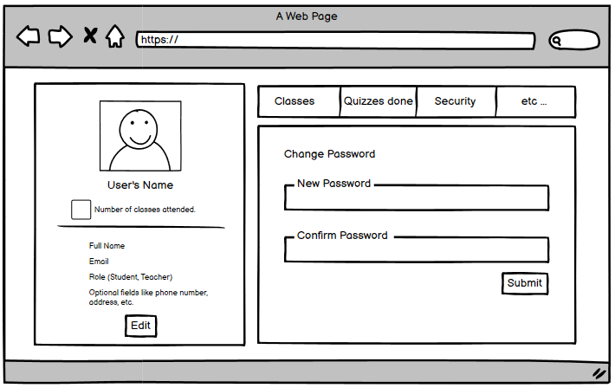

Figure 15.Change Password
- Function Details:
  - Data Requirements: The system needs the user’s current password and the new password they wish to set.
- Actions:
  - Change password: Users must enter their current password, and new password, and confirm the new password.
  - Save Changes: After validation, the new password is saved and updated.
  - Cancel Changes: Users can cancel the process and return without making any changes.
- Validation and Business Rules:
  - In normal cases:
    - The system verifies and updates the current password with the new one, notifying the user of the successful change.
  - In abnormal cases:
    - Incorrect current password: If the user enters the wrong one, an error message prompts them to try again.
    - New password validation failure: If the new password does not meet security criteria (e.g., too short, missing required characters), the user will receive a validation error message with guidelines for correcting the issue.

3.3.6 View Field Detail
- Function Trigger: Users access the Field Detail feature from the pickleball47 system to view specific court information.
- Function Description:
  - Actors/Roles: Players, Administrators.
  - Purpose: To provide users with detailed information about a selected pickleball court.
To help players and coaches plan their training sessions effectively.
  - Interface:
    - Name Field
    - Type Field
    - Starttime
    - Endtime
    - Price
- Data Processing:
  - The system stores, retrieves, and updates calendar events based on user interactions, ensuring that all changes are reflected accurately.
- Screen Layout:
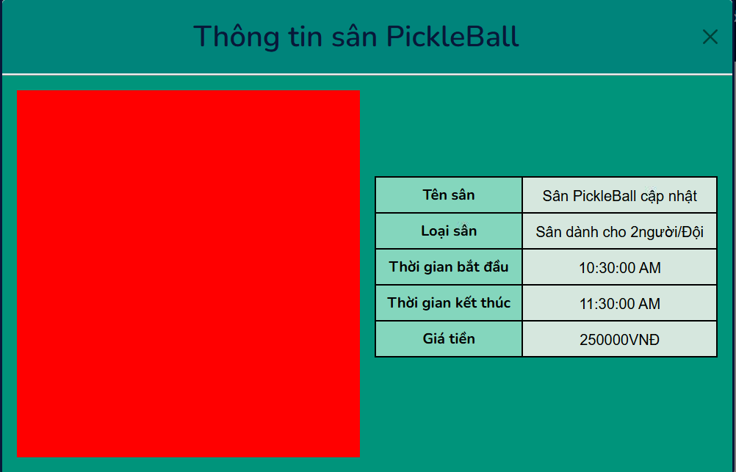

Figure 16. View Field Detail
- Function Details:
  - Data Requirements: The system requires event details, including:
    - Field ID
    - Name
    - Address/Location
    - Availability schedule
    - Court surface type
    - Capacity and amenities
- Actions:
- Users can:
  - Select a court from the list to view details.
  - See availability and schedule.
  - Access additional information about the court.

Validation and Business Rules:

In normal cases:
- Field details are successfully retrieved and displayed to the user.
- Updates made by administrators (e.g., changes in availability) are reflected accurately.

In abnormal cases:
- Data retrieval errors: If a network issue prevents loading field details, an error message is shown, and users are prompted to retry.
- Invalid field selection: If the selected court no longer exists, users are informed and redirected to the main field list.

3.3.7 Book Field
- Function Trigger: Users access the Field Booking feature from the pickleball47 system to reserve a pickleball field.
- Function Description:
  - Actors/Roles: Players.
Purpose: Allow users to book courts in advance for practice or matches.
Prevent conflicts caused by overlapping reservations.
  - Interface:
    - Select a court from the available list.
    - Choose a time slot (date, start time, end time)
    - Confirm booking details before finalizing.
    - payment
    - Cancel or modify bookings if changes are needed.
- Data Processing:
• The system checks court availability based on existing reservations.
• If the court is available, the system saves the booking details in the database.
• The court status is updated to prevent double bookings..
- Screen Layout:
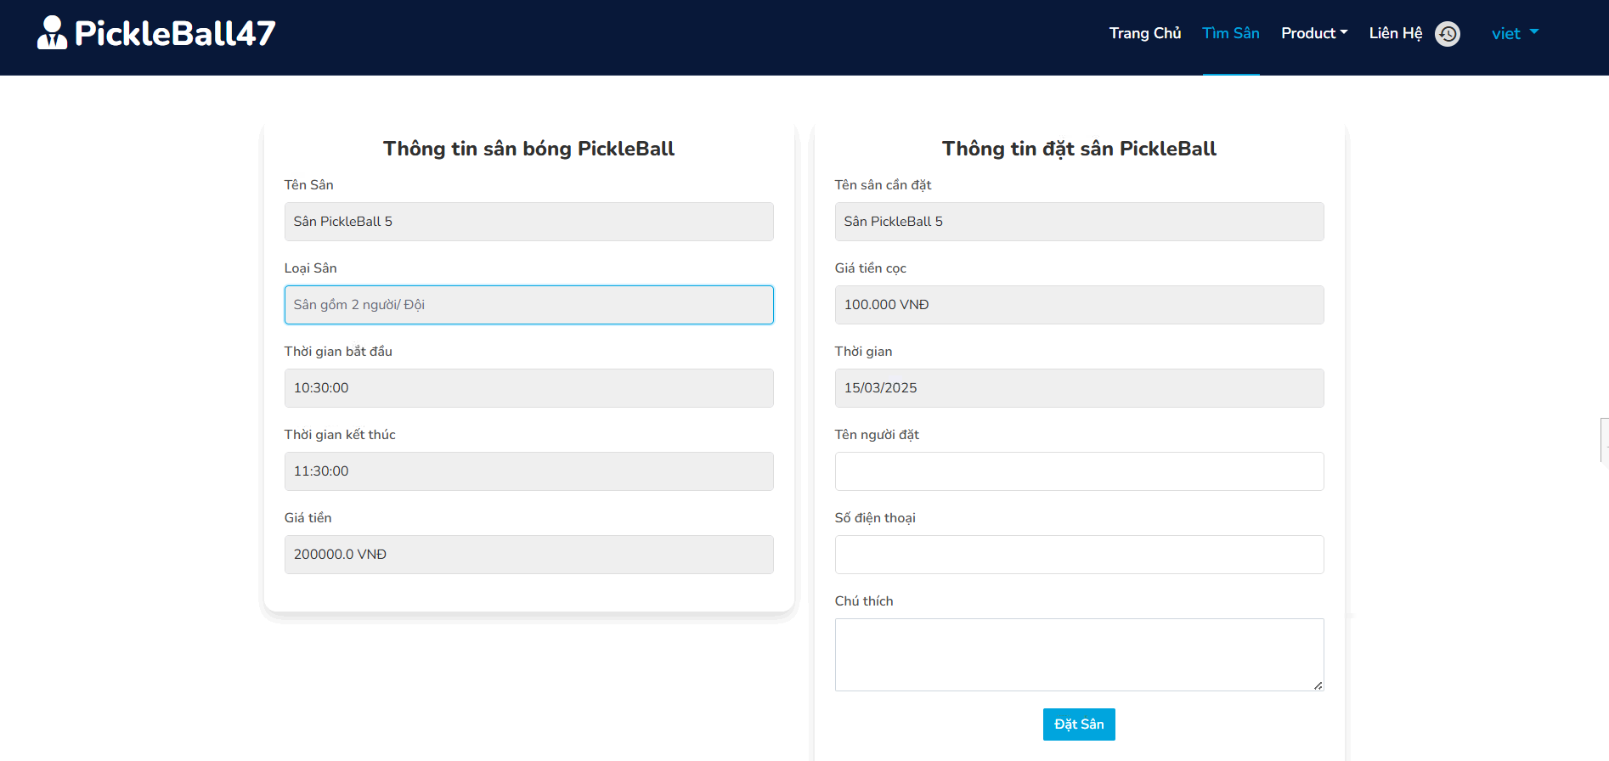

Figure 17.Booking Field
- Function Details:
  - Data Requirements: The system requires event details, including:
    - User ID (person making the booking)
    - Field ID (selected court)
    - Date, Start Time, End Time
    - Optional notes (e.g., number of players, requested equipment).
- Actions:
- Users can:
  - Search for courts based on location, surface type, or availability.
  - Select a court and schedule a booking.
  - Cancel or modify a booking (if the time has not yet started).
  - Receive a confirmation notification upon successful booking.

Validation and Business Rules:

Normal Cases:
- Booking is successful if the court is available during the requested time.
- The court status is updated to prevent scheduling conflicts.
- Users can cancel or modify bookings before the start time.

Abnormal Cases:
- Court is already booked: Display a notification and suggest alternative time slots.
- System error during booking: Show an error message and allow users to retry.
- User tries to modify/cancel a booking after the start time: Display a warning that changes are not allowed.

3.3.8 Paymment

Function Trigger:
Users access the Payment feature to complete their court booking through VNPay.

Function Description:
- Actors/Roles: Players, Coaches.
- Purpose:
  - Allow users to make secure online payments for court reservations.
  - Ensure a seamless transaction process integrated with VNPay.

Interface:
- Choose payment method: VNPay (QR code, banking app, credit/debit card).
- Confirm booking details and total price.
- Redirect to VNPay payment gateway for transaction processing.
- Receive payment confirmation and booking receipt.

Data Processing:
- The system generates a payment request and redirects users to VNPay.
- VNPay processes the payment and sends the result back to the system.
- If successful, the booking status updates to Paid.
- If failed, the user is notified and can retry the payment.

- Screen Layout:
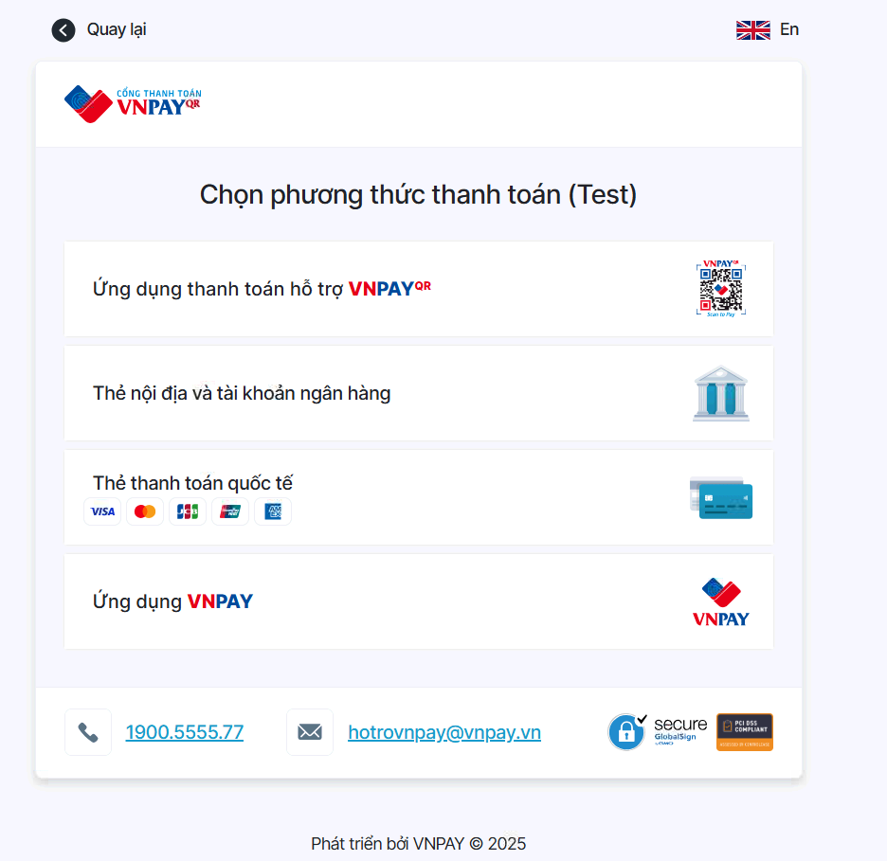

Figure 18.Payment

Function Details:
- Data Requirements:
  - Booking ID (to track the reservation).
  - User ID (payer’s identification).
  - Total Amount (calculated based on booking duration and court rate).
  - VNPay Transaction ID (for payment verification).
  - Payment Status (Pending, Paid, Failed).

Actions:
- Users can:
  - Choose VNPay as the payment method.
  - View booking details and confirm the amount.
  - Proceed with payment via VNPay gateway.
  - Receive a confirmation email and receipt upon successful payment.

Validation and Business Rules:

Normal Cases:
- Payment is successfully processed, and the system updates the booking status to Paid.
- Users receive a payment confirmation notification.

Abnormal Cases:
- Payment failed: Display an error message and allow retry.
- Transaction timeout: Inform users and redirect them to retry payment.
- Payment completed but booking not updated: The system checks VNPay transaction logs and updates the booking manually if necessary.

3.3.9 View Booking History

Function Trigger:
Users access the Booking History feature to view their past and upcoming court reservations.

Function Description:
- Actors/Roles: Players, Coaches.
- Purpose:
  - Allow users to track their past and future court bookings.
  - Provide quick access to booking details, status, and payment history.

Interface:
- List of past and upcoming bookings with filters (e.g., date, status).
- View detailed booking information, including:
  - Booking ID
  - Court name & location
  - Date & time
  - Duration
  - Booking status (Pending, Paid, Canceled, Completed)
  - Payment details (Paid via VNPay, amount, transaction ID)
- Options to:
  - Download invoice for completed bookings.
  - Cancel upcoming bookings (if allowed by policy).
  - Rebook the same court for a future date.

Data Processing:
- The system retrieves and displays all booking records associated with the user.
- Booking data is fetched from the database and sorted by date/status.
- If a booking is canceled, the system checks refund eligibility (if payment was made).

- Screen Layout:
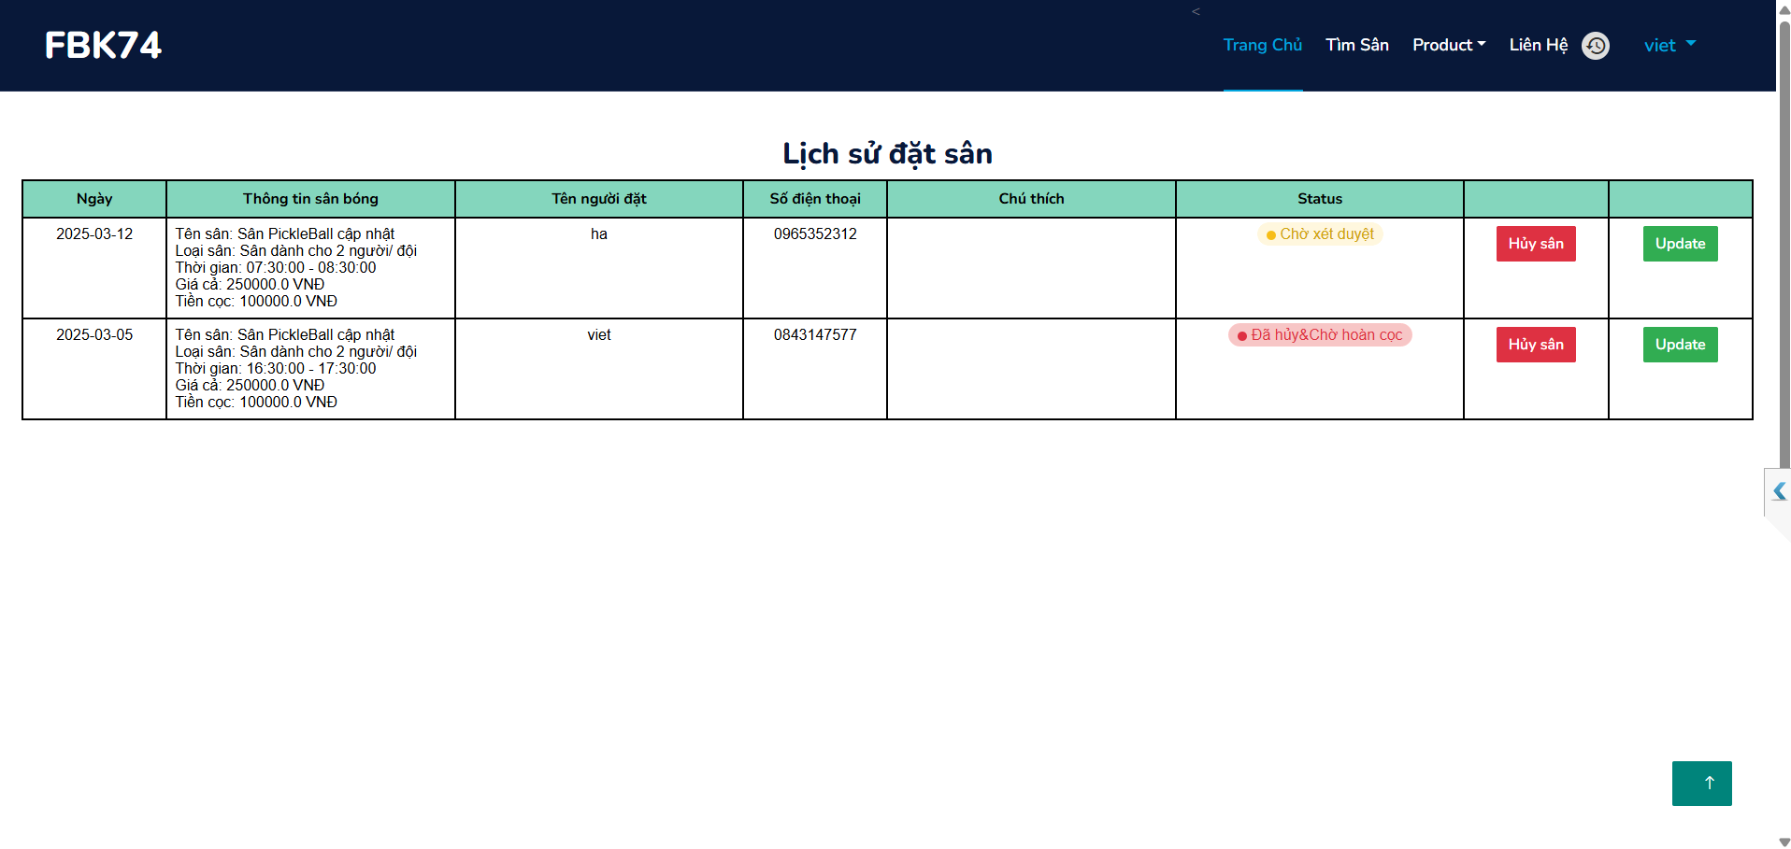

Figure 19.Delete Personal Calendar

Function Details:
- Data Requirements:
  - User ID (to fetch user-specific bookings).
  - Booking details (court, date, time, price, status).
  - Payment details (if applicable).

Actions:
- Users can:
  - Filter and search booking history by date, court, or status.
  - View and download booking invoices.
  - Cancel bookings before the allowed deadline.
  - Rebook a previous reservation with one click.

Validation and Business Rules:

Normal Cases:
- Users can see all past and future bookings.
- Users can successfully cancel or rebook when applicable.

Abnormal Cases:
- No booking records found: Display a message indicating no bookings.
- Attempt to cancel past bookings: Show an error message stating cancellations are only allowed before the booking time.
- Payment issues: If a payment is marked as completed but booking details are missing, users are prompted to contact support.

3.3.10 Cancel Booking

Function Trigger:
Users access the Cancel Booking feature to cancel a previously made court reservation.

Function Description:
- Actors/Roles: Players, Coaches.
- Purpose:
  - Allow users to cancel a court booking if they no longer need it.
  - Free up the court for other players.
  - Process refunds if applicable.

Interface:
- View list of upcoming bookings with a Cancel button.
- Select a booking to cancel and review details.
- Confirm cancellation with potential refund information (if applicable).
- Receive a cancellation confirmation message.

Data Processing:
- The system verifies the cancellation policy (e.g., time before reservation starts).
- If eligible, the system updates the booking status to Canceled.
- If payment was made via VNPay, the system processes a refund based on the policy

- Screen Layout:
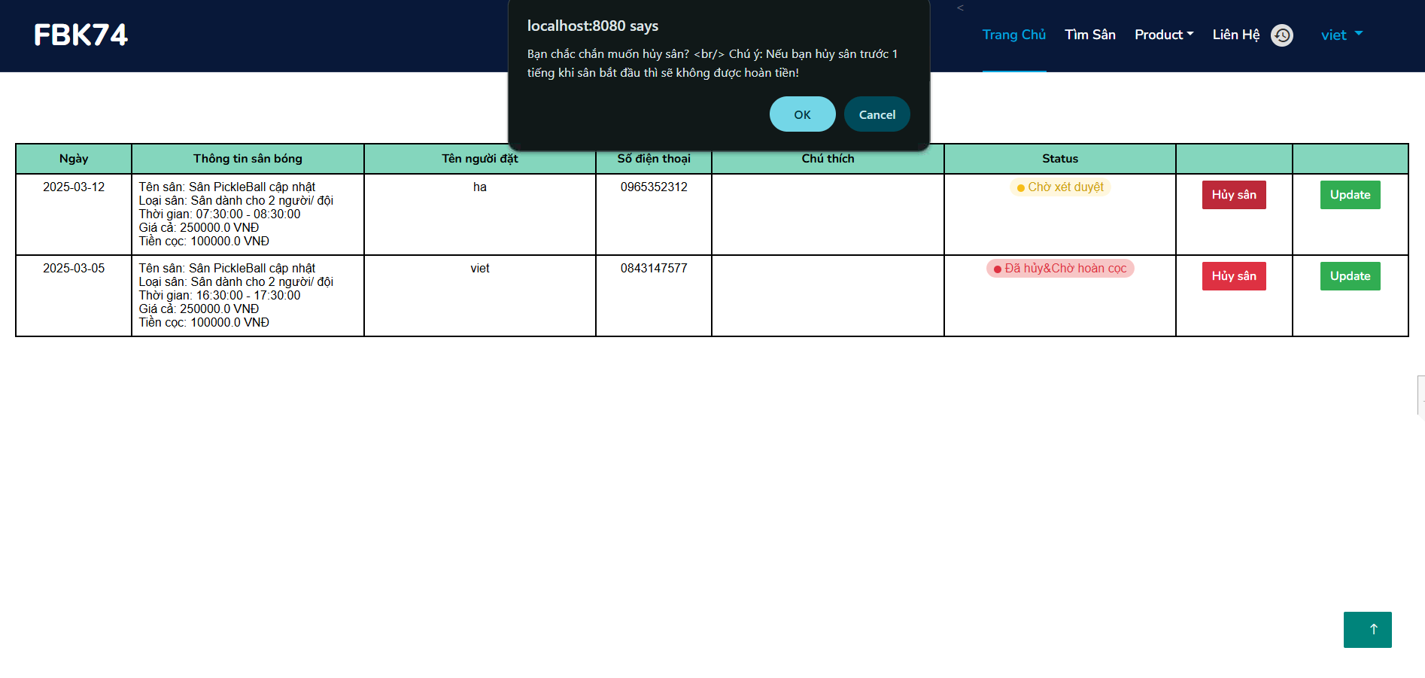

Figure 20. Cancel Booking

Function Details:
- Data Requirements:
  - User ID (to identify the user).
  - Booking ID (to track the reservation).
  - Cancellation deadline (e.g., cancellations allowed up to 24 hours before).
  - Payment status (to determine refund eligibility).

Actions:
- Users can:
  - Select a booking and request cancellation.
  - See cancellation policies and potential refunds.
  - Receive a cancellation confirmation and refund details.

Validation and Business Rules:

Normal Cases:
- If cancellation is within the allowed period, the booking is successfully canceled.
- If a refund is applicable, it is processed automatically through VNPay.

Abnormal Cases:
- Cancellation deadline passed: Display an error message that cancellation is not allowed.
- Refund failure: Notify the user and provide customer support options.
- Booking already used/completed: Prevent cancellation and inform the user

3.3.11 Update Field

Function Trigger:
Admins access the Update Field feature to modify court details.

Function Description:
- Actors/Roles: Administrators.
- Purpose:
  - Allow admins to update court information, availability, and amenities.
  - Ensure users see accurate and up-to-date details when booking.

Interface:
- Select a court from the list.
- Edit field details, including:
  - Field Name
  - Location
  - Availability schedule
  - Surface type
  - Capacity
  - Amenities (e.g., lighting, locker rooms, seating)
- Save changes and confirm update.

Data Processing:
- The system retrieves the selected court's details.
- After modification, the system updates the database and reflects changes in the booking system
- Screen Layout: N/a

Function Details:
- Data Requirements:
  - Field ID (to track the court).
  - Updated attributes (any modified details).
  - Admin ID (for tracking changes).

Actions:
- Admins can:
  - Search for and select a field.
  - Edit field details.
  - Save and update changes in real time.

Validation and Business Rules:

Normal Cases:
- Field details are successfully updated and reflected in the system.
- Users see the latest availability and court information.

Abnormal Cases:
- Field not found: Show an error message if the field does not exist.
- Invalid data input: Prevent saving if required fields are missing or incorrect.
- Update failure: Notify the admin and allow retry

3.4 Buy Product
Users access the Buy Product feature to purchase pickleball-related items (e.g., paddles, balls, apparel).

Function Description:
- Actors/Roles: user.
- Purpose:
  - Allow users to buy products from the store.
  - Ensure a smooth checkout process with VNPay integration.

Interface:
- Browse product catalog (filtered by category, price, brand).
- Select a product to view details.
- Add to cart and adjust quantity.
- Proceed to checkout and enter shipping details.
- Choose payment method (VNPay, credit/debit card, bank transfer).
- Confirm order and complete payment.
- Receive order confirmation and tracking details.

Data Processing:
- The system validates stock availability.
- If available, the system generates an order ID and calculates the total price.
- After successful VNPay payment, the system updates order status and notifies the user.

Function Details:
- Data Requirements:
  - User ID (to link orders to a user).
  - Product ID (to identify items).
  - Quantity (to calculate stock and pricing).
  - Shipping address & contact info.
  - Payment details & transaction ID (if paid via VNPay).

Actions:
- Users can:
  - Search, filter, and browse products.
  - Add products to the cart and adjust quantities.
  - Complete checkout with secure payment.
  - Track order status (Pending, Paid, Shipped, Delivered).

Validation and Business Rules:

Normal Cases:
- Successful order placement updates the order history and stock levels.
- Users receive email/SMS confirmation.

Abnormal Cases:
- Product out of stock: Show an error message and suggest alternatives.
- Payment failure: Allow users to retry or select another payment method.
- Invalid shipping details: Prompt users to correct errors before checkout.

3.4.2 Update Booking Field
Users or admins access the Update Booking Field feature to modify an existing court reservation.

Function Description:
- Actors/Roles: Players, Coaches, Administrators.
- Purpose:
  - Allow users to update their booking details (date, time, court).
  - Ensure court availability is checked before modification.

Interface:
- View list of upcoming bookings.
- Select a booking to update.
- Modify booking details, including:
  - Court selection
  - Date & time
  - Duration
  - Additional notes (if applicable)
- Confirm changes and update booking.

Data Processing:
- The system checks court availability for the new date/time.
- If available, the system updates the booking record.
- If payment is involved, the system adjusts pricing accordingly (e.g., refund or extra charge if needed)

- Screen layout:
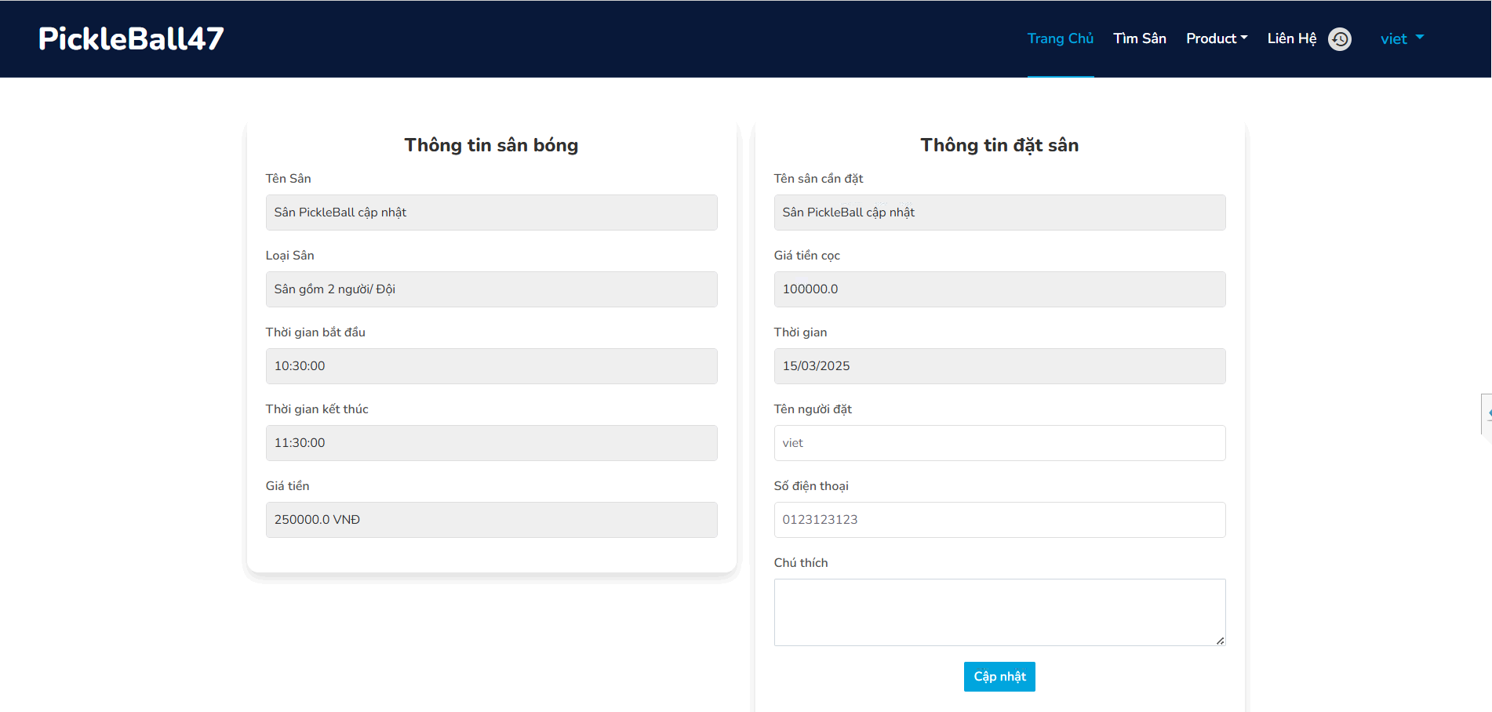

Figure 23.Update booking field

Function Details:
- Data Requirements:
  - Booking ID (to identify the reservation).
  - User ID (to verify ownership).
  - Updated booking details (new court, date, time).
  - Payment status (if modifications affect the cost).

Actions:
- Users/Admins can:
  - Select and modify a booking.
  - Change the court or time (if available).
  - Confirm the update and adjust payment if needed.

Validation and Business Rules:

Normal Cases:
- Booking is updated successfully, and users receive confirmation.
- Payment is adjusted if necessary.

Abnormal Cases:
- New court/time unavailable: Display an error message and suggest alternatives.
- Modification not allowed (e.g., too close to booking time): Prevent updates and inform the user.
- Payment adjustment failure: Notify the user and provide manual support options

3.4.3 VIew order history

Function Trigger:
Users access the Order History feature to track their past and current purchases.

Function Description:
- Actors/Roles: User.
- Purpose:
  - Allow users to view all past and ongoing product orders.
  - Provide details about order status, payments, and delivery tracking.

Interface:
- List of past and ongoing orders, with filters (e.g., date, status).
- View detailed order information, including:
  - Order ID
  - Product name & quantity
  - Total price
  - Order status (Pending, Paid, Shipped, Delivered, Canceled)
  - Payment details (VNPay transaction ID, amount, method)
  - Shipping details (Address, tracking number)
- Options to:
  - Download invoices for completed orders.
  - Cancel pending orders (if allowed by policy).
  - Reorder previous purchases quickly.

Data Processing:
- The system retrieves all orders linked to the user.
- Orders are sorted by date and status.
- If an order is canceled, the system checks refund eligibility (if payment was made).

Function Details:
- Data Requirements:
  - User ID (to fetch user-specific orders).
  - Order details (products, date, price, status).
  - Payment details (if applicable).
  - Shipping details (for tracking).

Actions:
- Users can:
  - Search, filter, and browse order history.
  - View and download invoices.
  - Cancel orders (if within cancellation policy).
  - Reorder past items with one click.

Validation and Business Rules:

Normal Cases:
- Users see all their past and current orders.
- Users can successfully cancel or reorder if applicable.

Abnormal Cases:
- No order records found: Show a message indicating no past orders.
- Attempt to cancel shipped orders: Display an error message stating cancellations are only allowed before shipment.
- Payment issues: If an order is marked as paid but missing details, prompt the user to contact support.

3.4.4 Delete Answer slot question
Users access the Cancel Order feature to cancel a product purchase before it is shipped.

Function Description:
- Actors/Roles: User.
- Purpose:
  - Allow users to cancel orders if they no longer need the items.
  - Ensure that cancellations comply with store policies.
  - Process refunds through VNPay if applicable.

Interface:
- View list of pending orders with a Cancel button.
- Select an order to cancel and review details.
- Confirm cancellation, with refund information (if applicable).
- Receive cancellation confirmation message.

Data Processing:
- The system verifies the cancellation policy (e.g., only before shipment).
- If eligible, the system updates the order status to Canceled.
- If payment was made via VNPay, the system processes a refund according to the policy.

Function Details:
- Data Requirements:
  - User ID (to verify the order belongs to the user).
  - Order ID (to track the purchase).
  - Order status (to check if it’s still cancelable).
  - Payment status (to determine refund eligibility).

Actions:
- Users can:
  - Select an order and request cancellation.
  - View cancellation policies and potential refunds.
  - Receive confirmation and refund details.

Validation and Business Rules:

Normal Cases:
- If the order is pending and cancellation is within the allowed time, the system successfully cancels it.
- If a refund is applicable, it is processed automatically via VNPay.

Abnormal Cases:
- Order already shipped: Display an error message that cancellation is no longer allowed.
- Refund failure: Notify the user and provide customer support options.
- Invalid order ID: Prevent cancellation and inform the user

3.4.5 Manage users acoount
Admins access the User Management feature to manage player and coach accounts.

Function Description:
- Actors/Roles: Administrators.
- Purpose:
  - Allow admins to create, update, deactivate, or delete user accounts.
  - Maintain security and user role management.

Interface:
- List of all registered users, with search and filter options (e.g., by role, status).
- Actions available per user:
  - Create new user account (manual registration for special cases).
  - Edit user details (name, email, phone, role).
  - Reset password (force reset and send a new password via email).
  - Deactivate account (restrict access without deletion).
  - Delete account (permanent removal).
  - Change user roles (Player ↔ Coach ↔ Admin).

Data Processing:
- The system retrieves user details from the database.
- When updating a user, changes are validated before saving.
- If a password reset is triggered, the system generates a secure temporary password

- Screen layout:
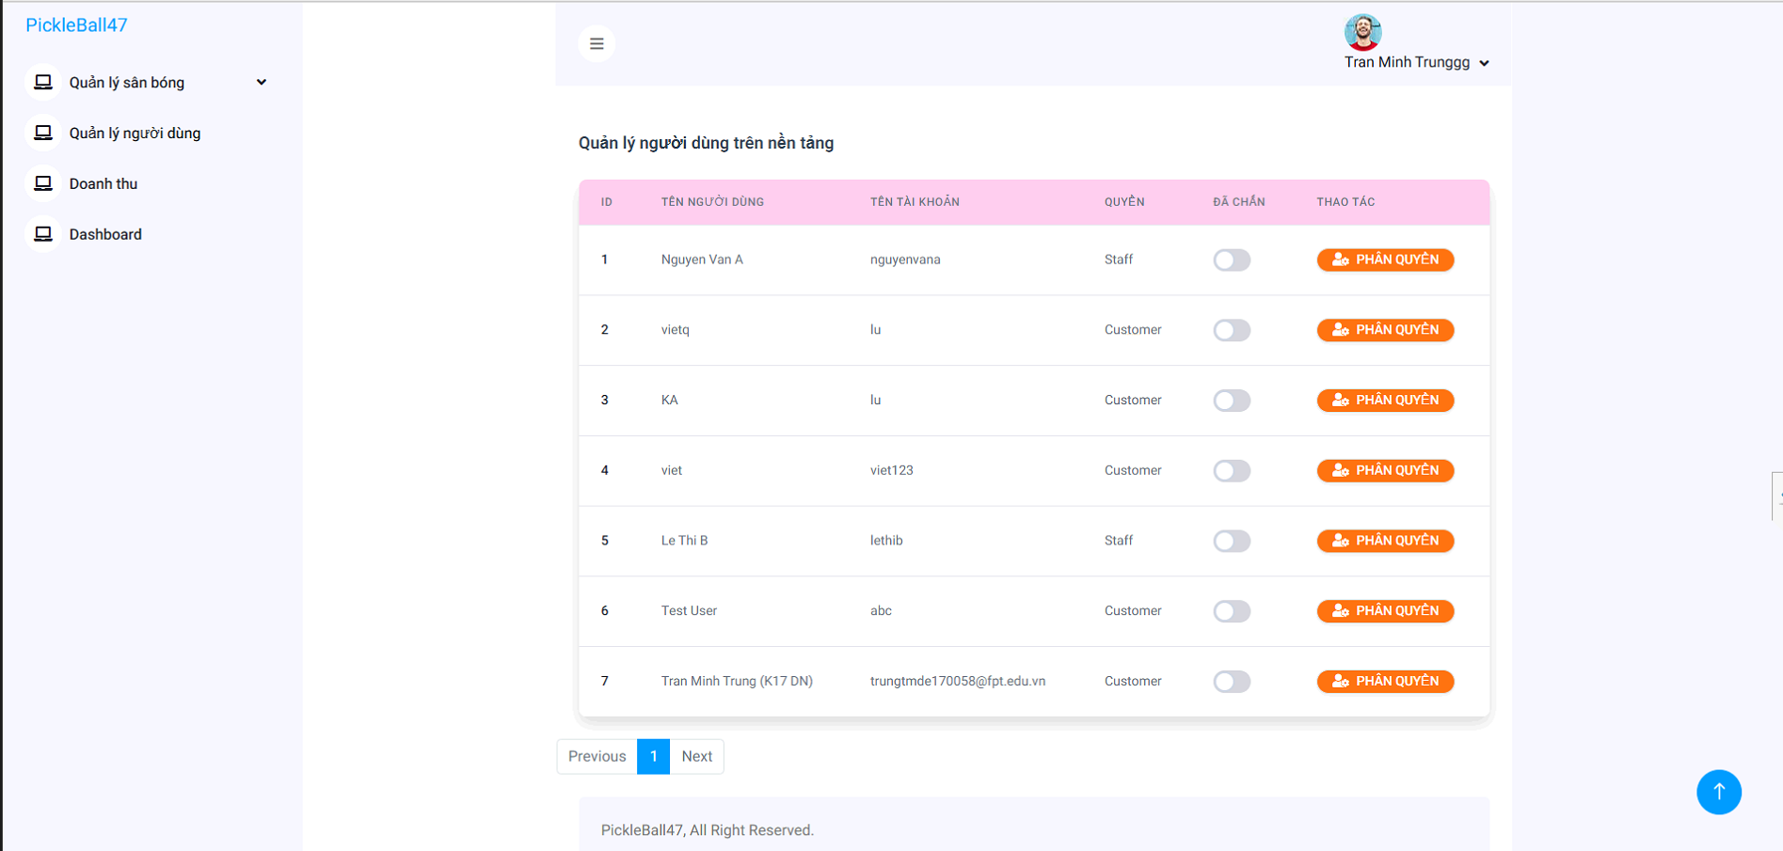
Figure 26.Manage User

Function Details:
- Data Requirements:
  - User ID (to identify the account).
  - Personal details (name, email, phone, role).
  - Account status (Active, Inactive, Deleted).
  - Role permissions (Player, Coach, Admin).

Actions:
- Admins can:
  - Search and filter users.
  - Edit or reset user credentials.
  - Suspend or delete accounts.
  - Change user roles and permissions.

Validation and Business Rules:

Normal Cases:
- Admins successfully create, edit, or deactivate user accounts.
- Users receive email notifications for password resets or role changes.

Abnormal Cases:
- Attempt to delete an admin account: Restrict deletion unless another admin exists.
- Invalid email format: Prevent updates and show a validation error.
- Inactive users trying to log in: Display an error message about account status

3.4.6 Manage Product Sport
Admins access the Product Management feature to manage pickleball-related products.

Function Description:
- Actors/Roles: Administrators.
- Purpose:
  - Allow admins to add, edit, remove, or update stock for products.
  - Ensure accurate product listings for users.

Interface:
- Dashboard with product list, including filters (category, price, stock status).
- Actions available per product:
  - Add new product (enter details, upload images).
  - Edit product details (name, price, description, category).
  - Update stock quantity (increase/decrease inventory).
  - Deactivate product (hide from users but keep records).
  - Delete product (permanent removal).

Data Processing:
- The system validates inputs before saving changes.
- If stock updates affect active orders, admins get notified.
- If a product is deactivated or deleted, it is removed from the storefront but remains in the database for reporting.

Function Details:
- Data Requirements:
  - Product ID (unique identifier).
  - Name & description (to display in the store).
  - Category (e.g., paddles, balls, apparel).
  - Price & stock quantity (for inventory tracking).
  - Images (for user display).

Actions:
- Admins can:
  - Add and update product listings.
  - Manage inventory levels.
  - Adjust pricing and promotions.
  - Remove or deactivate items.

Validation and Business Rules:

Normal Cases:
- Product details update successfully and reflect in the store.
- Stock adjustments update inventory in real time.

Abnormal Cases:
- Invalid price/stock entry: Prevent saving if values are incorrect.
- Attempt to delete a product with active orders: Display an error and suggest deactivation instead.
- Image upload failure: Prompt admin to retry or check file format

3.4.7 Manage Field

Function Trigger:
Admins access the Field Management feature to manage pickleball courts and rental availability.

Function Description:
- Actors/Roles: Administrators.
- Purpose:
  - Allow admins to add, update, remove, or manage availability of pickleball courts.
  - Ensure real-time field availability for bookings.

Interface:
- Dashboard with a list of all fields, including filters (location, size, status).
- Actions available per field:
  - Add a new field (enter details, upload images).
  - Edit field details (name, location, price per hour).
  - Manage availability (open/close for booking).
  - Deactivate field (temporarily remove from booking options).
  - Delete field (permanently remove from the system).

Data Processing:
- The system validates inputs before saving changes.
- If a field is deactivated or deleted, active bookings are notified.
- The system ensures no double bookings when modifying availability

- Screen layout:

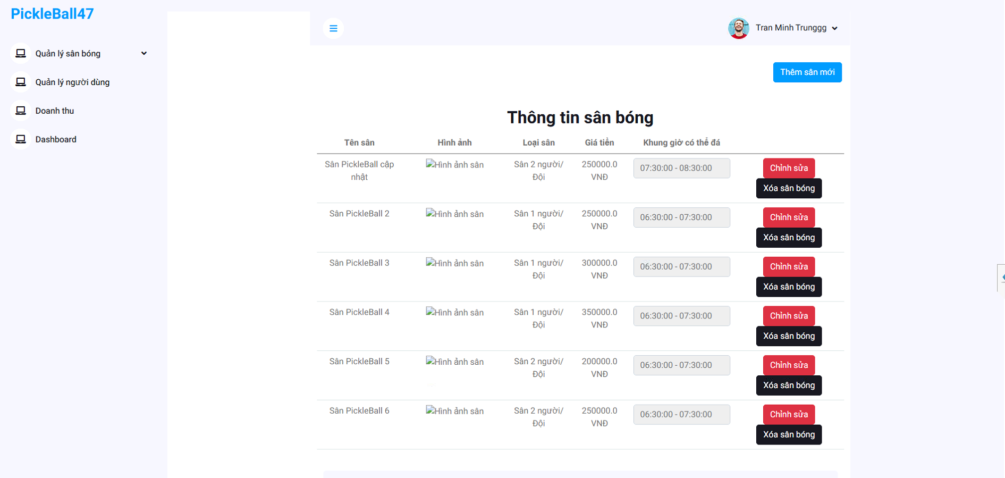

Figure 28.Manage Field

Function Details:
- Data Requirements:
  - Field ID (unique identifier).
  - Name & description (for display in booking system).
  - Location (court address or area).
  - Size & type (e.g., indoor/outdoor).
  - Price per hour (for rental calculation).
  - Availability schedule (open hours).
  - Images (for user display).

Actions:
- Admins can:
  - Add new courts to the system.
  - Edit field details, including pricing and availability.
  - Disable fields for maintenance or temporary closure.
  - Remove unused fields.

Validation and Business Rules:

Normal Cases:
- Field details update successfully and reflect in the booking system.
- Availability updates prevent overbooking conflicts.

Abnormal Cases:
- Attempt to delete a field with active bookings: Display an error and suggest deactivation instead.
- Invalid price or schedule entry: Prevent saving and request correct values.
- Image upload failure: Prompt admin to retry or check file format.

3.4.8 Manage Booking from user

Function Trigger:
Admins access the Booking Management feature to view, approve, reject, or modify user court reservations.

Function Description:
- Actors/Roles: Administrators.
- Purpose:
  - Allow admins to review and approve user bookings.
  - Ensure court availability and prevent scheduling conflicts.
  - Manage booking modifications and cancellations.

Interface:
- List of all bookings, with filters (date, status, user).
- Actions available per booking:
  - Approve booking (confirm reservation and notify user).
  - Reject booking (with a reason for rejection).
  - Modify booking details (change date, time, court if needed).
  - Cancel booking (remove from system and process refunds if applicable).
  - View payment details (check VNPay transaction).

Data Processing:
- The system ensures no double bookings before approval.
- If a booking is approved, the system updates availability.
- If a booking is rejected, the system notifies the user with a reason.
- If a booking requires payment confirmation, VNPay transaction details are checked

- Screen layout:
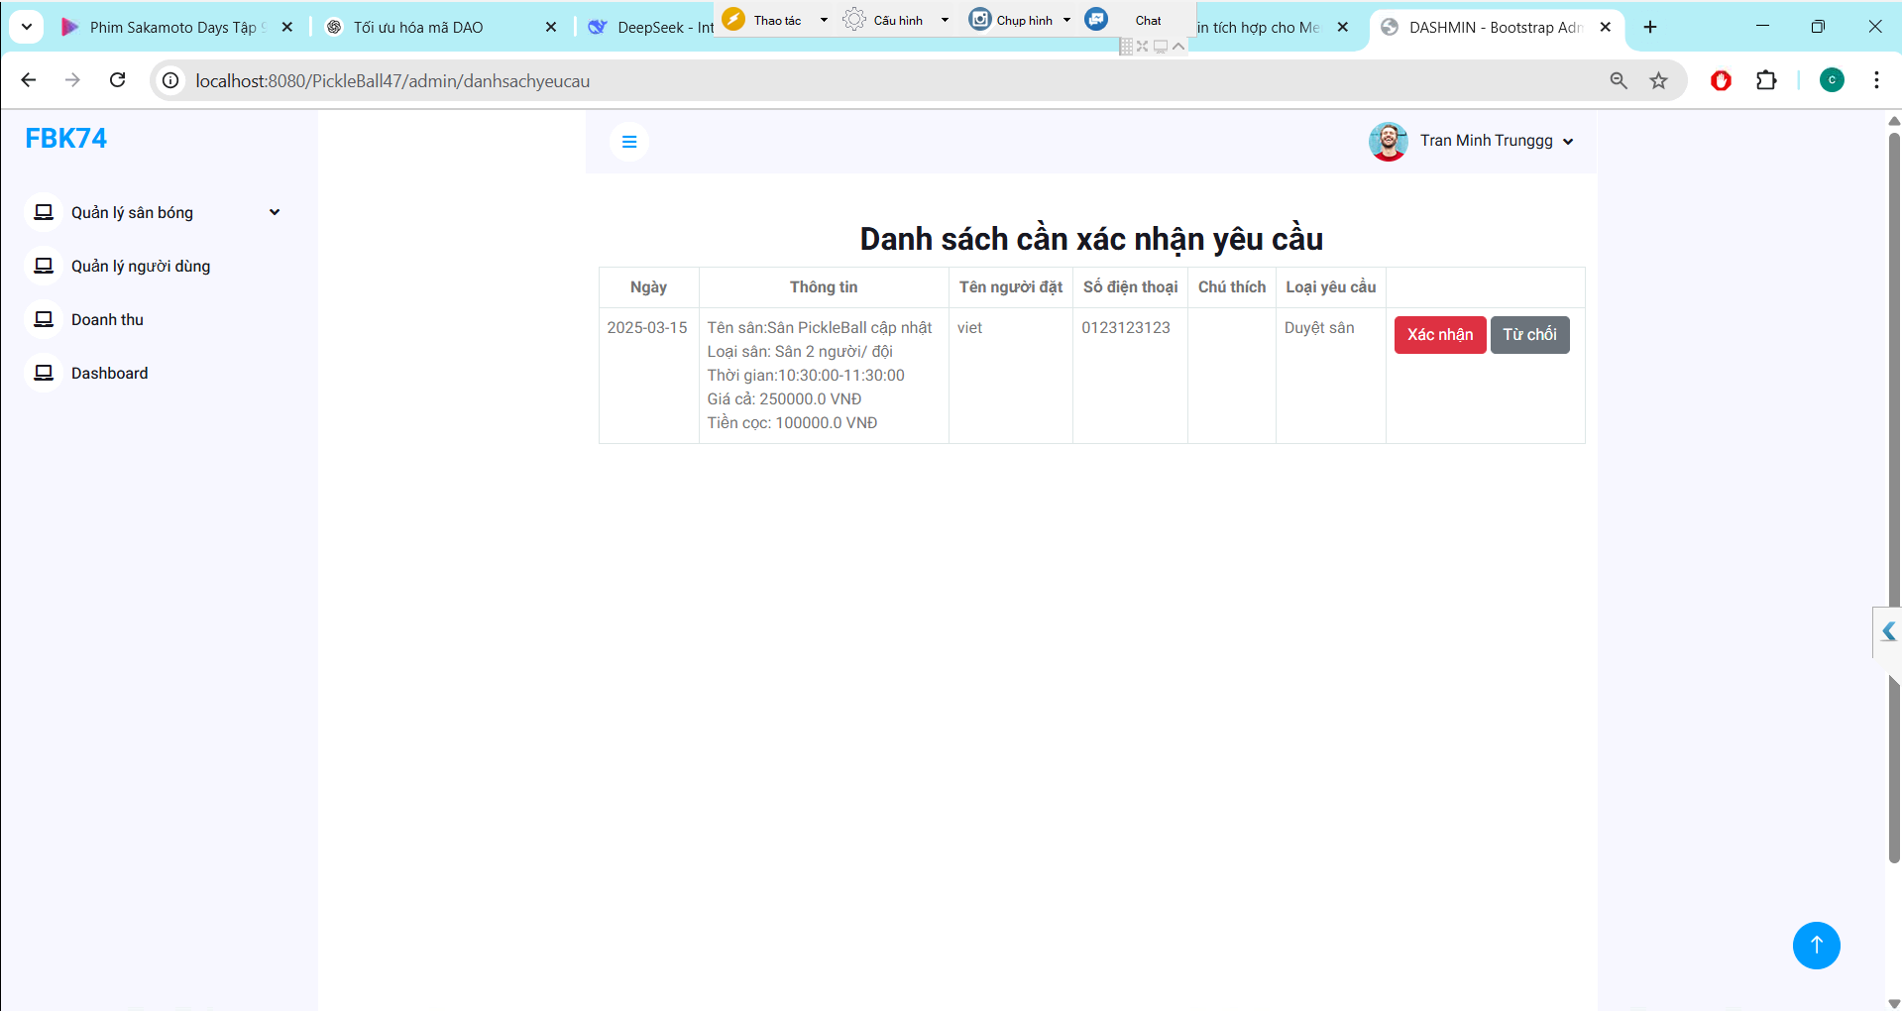

Figure 29.Manage Booking From user

Function Details:
- Data Requirements:
  - Booking ID (unique identifier).
  - User details (who made the reservation).
  - Court details (which field is booked).
  - Date & time (reservation schedule).
  - Status (Pending, Approved, Rejected, Canceled).
  - Payment details (if applicable).

Actions:
- Admins can:
  - Approve or reject pending bookings.
  - Modify or cancel existing reservations.
  - Check VNPay transactions for payment verification.
  - Notify users of booking status updates.

Validation and Business Rules:

Normal Cases:
- If a booking is approved, it becomes final and reflects in the system.
- If a booking is rejected, the system sends a notification.
- If a paid booking is canceled, the system processes a refund according to policy.

Abnormal Cases:
- Attempt to approve an already-booked court: Display a conflict error and suggest rescheduling.
- Invalid payment details: Prevent approval and request user confirmation.
- User cancels after approval: Follow refund policy and notify admins

3.4.10 Manage order from user

Function Trigger:
Admins access the Order Management feature to approve, modify, or cancel user orders for sports products.

Function Description:
- Actors/Roles: Administrators.
- Purpose:
  - Allow admins to approve or reject product orders.
  - Ensure smooth order processing, shipping, and payment validation.
  - Manage stock availability and prevent order conflicts.

Interface:
- List of all orders, with filters (date, status, user, payment method).
- Actions available per order:
  - Approve order (confirm purchase and process shipment).
  - Reject order (with a reason, e.g., out of stock).
  - Modify order details (adjust quantity, change shipping info).
  - Cancel order (remove from system and process refunds if applicable).
  - Check VNPay transaction details (verify payment).

Data Processing:
- The system verifies payment confirmation before approval.
- If an order is approved, the system updates stock levels and notifies the user.
- If an order is rejected, the user gets notified with a reason.
- If a paid order is canceled, a refund process is triggered via VNPay.

Function Details:
- Data Requirements:
  - Order ID (unique identifier).
  - User details (who placed the order).
  - Product details (items, quantity, price).
  - Order status (Pending, Approved, Rejected, Canceled, Shipped).
  - Payment details (VNPay transaction ID, amount).
  - Shipping information (address, tracking number).

Actions:
- Admins can:
  - Approve or reject pending orders.
  - Modify or cancel existing orders.
  - Check VNPay payment transactions.
  - Notify users of order status updates.

Validation and Business Rules:

Normal Cases:
- Approved orders are processed for shipping.
- Rejected orders notify the user with a reason.
- Paid canceled orders follow the refund policy.

Abnormal Cases:
- Insufficient stock: Prevent approval and suggest modification.
- Payment failure: Block approval and request user confirmation.
- User cancels after approval: Follow refund policy and notify admins

3.4.11 View Dashboard Revenue

Function Trigger:
Admins access the Revenue Dashboard to track total earnings, order statistics, and financial trends.

Function Description:
- Actors/Roles: Administrators.
- Purpose:
  - Provide an overview of revenue performance from court bookings and product sales.
  - Track monthly, weekly, and daily earnings.
  - Analyze trends and payment data (including VNPay transactions).

Interface:
- Dashboard Overview (Key Metrics & Charts)
  - Total Revenue (sum of all approved transactions).
  - Revenue Breakdown (court bookings vs. product sales).
  - Pending Payments (orders or bookings awaiting confirmation).
  - Best-Selling Products & Most Booked Fields.
  - Monthly/Weekly/Daily Revenue Chart (line graph or bar chart).
  - Top Paying Users (list of high-value customers).

Data Processing:
- The system retrieves all approved orders & bookings to calculate revenue.
- If a refund is issued, the system deducts it from total earnings.
- Data updates in real-time as transactions occur

- Screen layout:
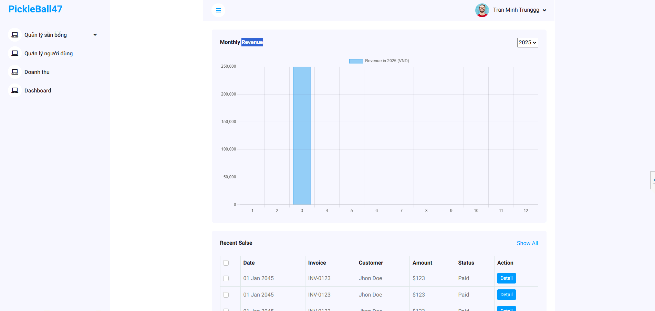

Figure 31.Dashboarh admin

Function Details:
- Data Requirements:
  - Transaction ID (unique identifier).
  - Order/Booking ID (linked purchase data).
  - Payment method (VNPay, cash, card).
  - Date & time of transaction.
  - Amount & status (successful, pending, refunded).

Actions:
- Admins can:
  - Filter revenue reports by date range.
  - Export data as CSV/PDF reports.
  - View detailed payment logs.
  - Identify trends in sales and bookings.

Validation and Business Rules:

Normal Cases:
- Revenue data updates accurately based on successful transactions.
- Charts and reports reflect real-time earnings.

Abnormal Cases:
- Discrepancies in revenue reports: Notify admin for manual review.
- Payment gateway issues: Flag transactions for verification.
- Refunded orders affecting totals: Ensure proper deduction in calculations

4. Non-Functional Requirements

4.1. External Interfaces

4.1.1 User Interface
- UI-01: When users complete any actions such as booking a court, purchasing a product, or updating their profile, the system must display a Success toast Message.
- UI-02: Whenever a user wants to cancel a reservation or delete an order, a confirmation popup message will appear with Yes/Cancel options.
- UI-03: All pages in the user system must include a Header menu or a Navigation menu for easy navigation.

4.1.2 Software Interface
- SI-01: Users can log in using Google services to authenticate their accounts securely.
- SI-02: The API should perform efficiently, handling booking and order requests quickly without excessive resource consumption.
- SI-03: The API must include JWT in the header when accessing private or secure resources.
- SI-04: The API for different services (e.g., court booking, product sales) must be independent and have minimal dependencies on each other.
- SI-05: The API should have a clear versioning strategy to manage changes and maintain compatibility with existing applications.

4.1.3 Hardware Interface
- HI-01: When connecting to the server, SSH keys must be used instead of IP and password authentication to enhance security.
- HI-02: The server must support scalable resources, such as increasing RAM when handling high user demand.

4.2. Quality Attributes

4.2.1 Availability
- The Pickleball47 Management System must be operational and accessible to users 95% of the time.
- The average time it takes to repair a system failure is a day.
- A strategy to recover from a major system failure or disaster.

4.2.2 Usability
- The system should be intuitive and easy for users to learn and operate, even for first-time users.
- Users should be able to remember how to use the system even after extended periods of inactivity.
- New features should be seamlessly integrated so users can quickly adapt.

4.2.3 Reliability
- To ensure continuous operation, the server must be available at least 28 days per month.
- User data, including booking history and purchase details, must be kept confidential and protected from unauthorized access.

4.2.4 Performance
- The system response time for user interactions should be no more than 2 seconds.
- Live chat support should ensure response times of <1 second.
- System data must be backed up every 2 weeks.

4.2.5 Security
- To prevent SQL injection, all data operations should be handled using parameterized queries or ORM functions
- The platform must implement security measures to protect user identities and ensure confidential transactions

4.2.6 Maintainability and Extensibility
- Project documentation must be well-organized and easily accessible for maintenance and future development.
- The codebase must be structured to facilitate easy maintenance, modifications, and future extensions.

5. Requirement Appendix

5.1 Business Rules
# | Rule Definition
BR-01 | Users must create an account to book a court and make purchases online.
BR-02 | Courts can be booked up to 14 days in advance.
BR-03 | Each booking must be for a minimum of 1 hours and a maximum of 4 hours.
BR-04 | A user can have a maximum of 3 active reservations at a time.
BR-05 | Cancellations must be made at least 24 hours before the reservation for a full refund.
BR-06 | No-shows will result in a penalty fee and potential suspension of booking privileges.
BR-07 | If a court is unoccupied for more than 15 minutes after the start time, it may be reassigned to walk-in customers.
BR-08 | Court availability updates must be displayed in real time on the platform.
BR-09 | Orders must be paid in full before pickup
BR-11 | Returns and exchanges are allowed within 7 days of purchase with a valid receipt.
BR-12 | Customized or clearance items are non-refundable.
BR-13 | Discounts and promotions cannot be combined unless explicitly stated.
BR-14 | Orders placed before 3 PM will be processed the same day; orders after 3 PM will be processed the next business day.
BR-15 | Damaged or defective products must be reported within 48 hours of delivery for a replacement or refund.
BR-16 | The system must notify customers via email for order confirmations, shipping updates, and invoices.
BR-17 | Cancellation before 1 hour of start will result in loss of deposit.

Table 7. Business Rule

5.2 Common Requirements
# | Requirement | Description
1 | Functionality | - FR-01: The system must allow users to book courts, purchase sports products, and manage their profiles.  - FR-02: Admins should have the ability to approve, modify, or cancel bookings and orders.  - FR-03: Users should be able to search for available courts and products using filters.  - FR-04: The system must send notifications for bookings, cancellations, and order status updates.  - FR-05: The system must support multiple payment methods (credit cards, PayPal, etc.).
2 | Security | - SEC-01:Sensitive user data (payment details, personal info) must be encrypted.  - SEC-02: Authentication must use JWT tokens for secure API access.  - SEC-03: Role-based access control (RBAC) must be implemented for different user levels.  - SEC-04: The system should have protection against SQL injection, XSS, and CSRF attacks.
3 | Performance | - PERF-01: The system response time must not exceed 2 seconds under normal load.  - PERF-02: Booking and purchase transactions should be processed within 3 minutes.  - PERF-03: Chat and real-time notifications must have a latency of <3 second.  - PERF-04: The system should efficiently handle at least 100 concurrent users.
4 | Scalability | - SCAL-01: The system should support an increasing number of users, bookings, and sales transactions.  - SCAL-02: The database must be optimized for scalability, using indexing and partitioning.  - SCAL-03: APIs must be stateless and scalable to support microservices architecture.  - SCAL-04: The server infrastructure should allow auto-scaling to handle traffic spikes.  - SCAL-05: The system should use caching strategies to improve load performance.
5 | Compatibility | - COMP-01: The system must support all modern web browsers (Chrome, Firefox, Edge, Safari).  - COMP-02: The platform must be mobile-responsive for smartphones and tablets.  - COMP-03: The API should support integration with third-party services like Google Auth.  - COMP-04: The system should work on Windows, macOS, iOS, and Android devices.  - COMP-05: The platform should allow exporting reports in multiple formats (PDF, Excel).
6 | Maintainability | - MAINT-01: The system code must follow clean architecture principles for easy updates.  - MAINT-02: All dependencies must be documented and kept up to date.  - MAINT-03: The database schema should be designed to allow future feature expansion.  - MAINT-04: The system must support logging and error tracking for debugging.  - MAINT-05: API versioning should be implemented to ensure backward compatibility.
7 | Quality | - QUAL-01: The system should undergo automated and manual testing to ensure reliability.  - QUAL-02: Bugs and issues should be tracked using a ticketing system.  - QUAL-03: The system should be tested under various user loads to measure performance.  - QUAL-04: Regular security audits must be conducted to identify vulnerabilities.  - QUAL-05: The UI/UX should be designed to enhance the overall user experience.
8 | Usability | - USAB-01: The platform should have an intuitive and user-friendly design.  - USAB-02: Users should be able to complete tasks with minimal clicks.  - USAB-03: The system should provide tooltips and help documentation.  - USAB-04: The font, colors, and contrast should be optimized for accessibility.  - USAB-05: The platform should remember user preferences for a personalized experience.
9 | Availability | - AVAIL-01: The system should maintain an uptime of at least 99.5%.  - AVAIL-02: Backups must be performed every 24 hours to prevent data loss.  - AVAIL-03: The system should automatically switch to a failover server in case of failure.  - AVAIL-04: Users should receive maintenance notifications in advance.  - AVAIL-05: The system should have a disaster recovery plan in place.

Table 8. Common Requirements

5.3 Application Messages List
# | Message code | Message Type | Context | Content
01 | MSG01 | Inline message | User Account Messages | Account created successfully. Welcome to [App Name]!
02 | MSG02 | Inline message | User Account Messages | Login successful. Redirecting to your dashboard...
03 | MSG03 | Inline message | User Account Messages | Invalid email or password. Please try again.
04 | MSG04 | Inline message | User Account Messages | Password updated successfully
05 | MSG05 | Inline message | User Account Messages | Your session has expired. Please log in again
06 | MSG06 | Inline message | User Account Messages | Account deactivated. Contact support for assistance
7 | MSG7 | Popup message | User Account Messages | Verification email sent. Please check your inbox
8 | MSG8 | Popup message | User Account Messages | Update Profile successfully
9 | MSG9 | Inline message | User Account Messages | Update Profile Fail
10 | MSG10 | Inline message | User Account Messages | Have a nice day! Lest’Play
11 | MSG11 | Inline message | Booking Messages | Court booked successfully! Your reservation is confirmed
12 | MSG12 | Toast message | Booking Messages | This court is already booked for the selected time
13 | MSG13 | Toast message | Booking Messages | You have reached the maximum number of active reservations
14 | MSG14 | Toast message | Booking Messages | Booking canceled successfully
15 | MSG15 | Toast message | Booking Messages | Cannot cancel booking within 24 hours of the scheduled time
16 | MSG16 | Toast message | Booking Messages | Your booking has been updated successfully
17 | MSG17 | Toast message | Booking Messages | Insufficient balance. Please add funds to proceed with the booking
18 | MSG18 | Toast message | Booking Messages | Court availability updated in real time
19 | MSG19 | Toast message | Booking Messages | Create slot fail
20 | MSG20 | Toast message | Booking Messages | You must be a registered member to book this court
21 | MSG21 | Toast message | Booking Messages | Booking failed due to a server error. Please try again later
22 | MSG22 | Toast message | Payment & Transactions Messages | Payment successful! Thank you for your purchase
23 | MSG23 | Toast message | Payment & Transactions Messages | Payment failed. Please check your payment details and try again.
24 | MSG24 | Toast message | Payment & Transactions Messages | Your refund has been processed successfully
25 | MSG25 | Toast message | Payment & Transactions Messages | Discount code applied successfully!
26 | MSG26 | Toast message | Payment & Transactions Messages | Invalid discount code. Please check and try again
27 | MSG27 | Toast message | Payment & Transactions Messages | Your transaction is being processed. Please do not refresh the page
28 | MSG28 | Toast message | Payment & Transactions Messages | Order confirmation email has been sent to your inbox
29 | MSG29 | Toast message | Payment & Transactions Messages | Loyalty points have been added to your account
30 | MSG30 | Toast message | Payment & Transactions Messages | Your payment method has been updated successfully
31 | MSG31 | Toast message | Payment & Transactions Messages | Subscription renewed successfully
32 | MSG32 | Toast message | Product Purchase Messages | Product added to cart successfully
33 | MSG33 | Toast message | Product Purchase Messages | Product removed from cart
34 | MSG34 | Toast message | Product Purchase Messages | Your order has been placed successfully
35 | MSG35 | Toast message | Product Purchase Messages | This product is currently out of stock
36 | MSG36 | Toast message | Product Purchase Messages | Shipping details updated successfully
37 | MSG37 | Toast message | Product Purchase Messages | Your order has been canceled
38 | MSG38 | Toast message | Product Purchase Messages | Estimated pickup date: [Date]
39 | MSG39 | Toast message | Product Purchase Messages | Your return request has been received. We will process it soon
40 | MSG40 | Toast message | Product Purchase Messages | Product review submitted successfully
41 | MSG41 | Toast message | Notification & System Alerts | You have a new message from [User Name]
42 | MSG42 | Inline message | Notification & System Alerts | Upcoming booking reminder: Your court reservation is tomorrow at [Time]
43 | MSG43 | Inline message | Notification & System Alerts | A new product has been added to our store! Check it out now.
44 | MSG44 | Toast message | Notification & System Alerts | System maintenance scheduled for [Date]. Expect temporary downtime
45 | MSG45 | Toast message | Notification & System Alerts | "Security alert: Unusual login detected. Please review your account activity."
46 | MSG46 | Toast message | Notification & System Alerts | You have successfully subscribed to our newsletter
47 | MSG47 | Toast message | Notification & System Alerts | A refund has been initiated to your payment method
48 | MSG48 | Toast message | Notification & System Alerts | Live chat is currently unavailable. Please try again later
49 | MSG49 | Toast message | Notification & System Alerts | An error occurred. Please contact support if the issue persists.

Table 9. Application Message List

